

**BIG DATA AND BUSINESS INTELLIGENCE MODULE**



**AtliQ - Supply chain Analysis**

**Name: Preethi Malyala**

**Student Id: W9566704**

Contents

**Executive Summary:** 3

**Introduction:** 5

Dataset Description: 5

Outline of Business Questions: 7

KEY FINDINGS and INSIGHTS: 8

Conclusions and Recommendations: 14

**ICA Appendix-BA Design** 15

**Data Pre-Processing and Data Cleaning:** 15

1. Data Loading: 15

2. First Row as Header: 18

3. Removing Null Values: 18

4. Renaming Columns: 19

5. Creating Tables in Power Query Editor: 20

6. Removing Columns: 26

**DATA MODELLING:** 27

**DAX Measures and Calculated Columns:** 30

**DASHBOARD EXPLORATORY ANALYSIS:** 36

**References:** 44

# **Executive Summary:**

**Overview:**

The main purpose of creating the business report is to perform the Supply Chain analysis of AtliQ mart based on the Orders and Target data which comprises of Products, Customers, Orders, Delivery details.

**Business Questions:**

* What is the average delay of orders from the agreed date?
* Which store has the highest delayed orders?
* Which products have been delayed the highest and what is the highest product quantity delayed?
* Are there any noticeable trends?
* Which city has the highest performance and which city does not?
* Which customers are achieving targets?

**Key Insights and Solutions:**

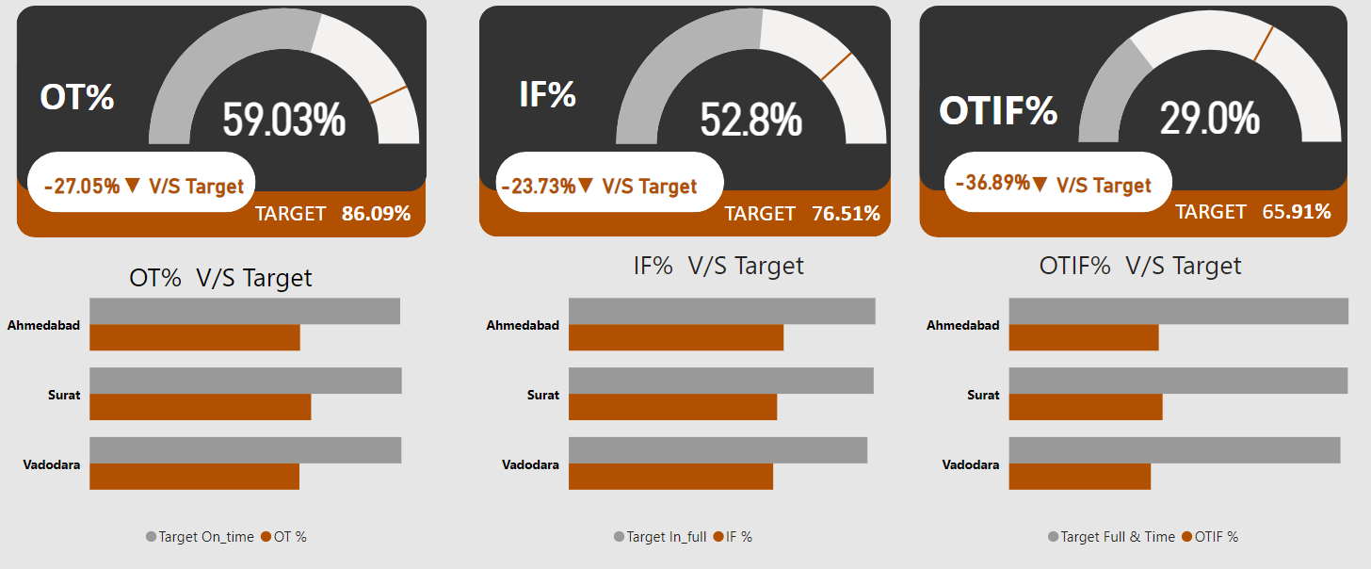

* On Time Delivery is 59.03% compared to the target of 86.09%
* In Full Quantity Delivery is 52.8% vs the target of 76.51%
* On Time and In-Full Delivery is at a surprising low of 29.0% compared to target of 65.91%

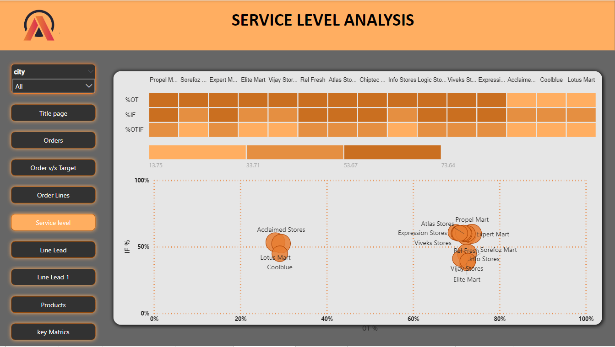

* **Acclaimed Stores, Lotus Mart and Coolblue** have the least OT% and OTIF% compared to any other stores which implies the delay is highest from these three stores.

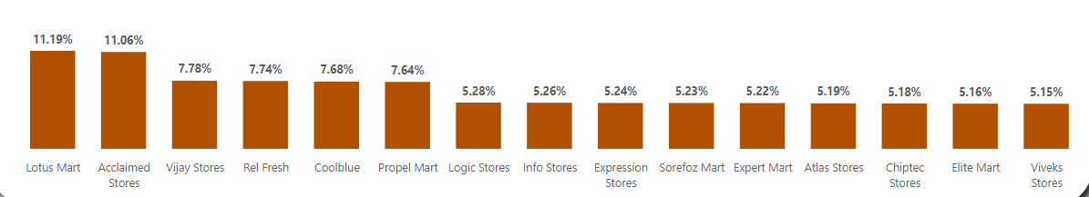

* **Lotus Mart, Acclaimed Stores** has the highest orders of all the stores and comprises of 22.25% of total sales.

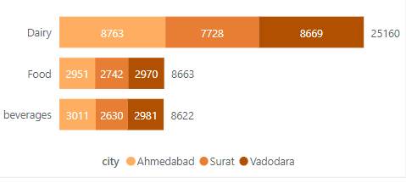

* **Dairy products** comprise of almost twice as many orders as both Food and Beverages combined. Also, Dairy products have the highest delay in orders among all products.
* **Ahmedabad and Vadodara** have almost the same number of delayed orders 5902 and 5891.

**Conclusions:**

Unfortunately, **Acclaimed Stores, Cool Blue & Lotus Mart** are the Key customers who would certainly not be willing to renew the contract as more than **75% of order lines are being delivered late** and they are having the highest number of orders. Moreover, out of **that 75% delayed deliveries**, **66% of them are late by 2 or 3 days**. The average **OTIF% is significantly lower than the Targeted OTIF %** Which shows poor delivering capabilities.

**Recommendations:**

Hence my recommendation for the AtliQ business is to focus on delivery management as delay in deliveries is the key hindrance to business development and retaining the customers.

More resources and infrastructure must be allocated for the Dairy products as they comprise of more than 70% of total orders.

Stores like Coolblue, Lotus Mart & Acclaimed Stores be given more priority on delivering the products as they are the key customers despite having a 75% of order lines delay.

**Introduction:**

AtliQ mart is a fast-moving consumer goods company in India. It is currently operational in three cities Surat, Ahmedabad, and Vadodara. They want to expand to other metros/tier 1 cities in the next 2 years.  
  
The Company is currently facing a problem where a few key customers did not extend the annual contract due to service issues. It is speculated that some of the essential orders were either not delivered on time or not delivered in full quantity over a continued period, which could have resulted in bad customer service. Management wants to fix this issue before expanding to other cities and requested their supply chain analytics team to track the ’On time’ and ‘In Full’ delivery service level for all the customers on a daily basis so that they can respond swiftly to these issues.  
  
The Supply Chain team decided to use a standard approach to measure the service level in which they will measure ‘on-time delivery (OT) %’, ‘In-full delivery (IF) %’, and OnTime in full (OTIF) % of the customer orders on a daily basis against the target service level set for each customer.

### Dataset Description:

**Source:**

The dataset used here is AtliQ supply chain analysis. The dataset was obtained from Codebasics: "<https://codebasics.io/event/codebasics-resume-project-challenge>".

This dataset contains 2 tables whereas the first dataset consists of 57096 rows and 8 rows with the information on company products, customers, order id, orders placed to date, agreed-on the delivery date, order delivered date, ordered quantity, and delivered Quantity.  
  
Whereas the target orders table contains 35 rows and 4 columns. It contains information on the target of the customers based on on-time delivery, in full quantity, Ontime delivery, and Full quantity delivery.  
This dataset is selected because of the information it contains like quantity, dates, list of products, and Customers list. The data looks so clear to work on. Using PowerBi as a challenge in the small-scale company to generate the company performance report is my main aim.

**Dataset Description:**

The following tables show the description of the columns in the AtliQ-Supply chain analysis dataset:

|  |  |  |
| --- | --- | --- |
| **Index** | **Column** | **Description** |
| 1. | Customer Id | Unique Id of the Customers |
| 2. | Order Id | Unique Id of the Orders |
| 3. | Product Id | Unique Id of the Products |
| 4. | Ordered quantity | Quantity ordered by the Customers |
| 5. | Delivered Quantity | The quantity delivered to the customers |
| 6. | Ordered Placement Date | The date when the order got placed by the Customers |
| 7. | Agreed Delivery Date | The date agreed upon by the company to deliver the product |
| 8. | Delivered Date | The date when the products got delivered |
| 9. | Product name | Name of the Product |
| 10. | Customer name | Name of the customer |
| 11. | Customer City | City the Customer is located in |
| 12. | Product Category | The category of the product belongs to |

Table 1: Orders line table and description

|  |  |  |
| --- | --- | --- |
| **Index** | **column** | **Description** |
| 1. | customer_id | The unique Id of Customers |
| 2. | ontime_target | Average of On-Time Target |
| 3. | infull_target% | Average of In-Full Target |
| 4. | otif_target% | Average of OTIF Target |

Table 2: Target Orders list Table and description

The following Screenshots are the data in excel form

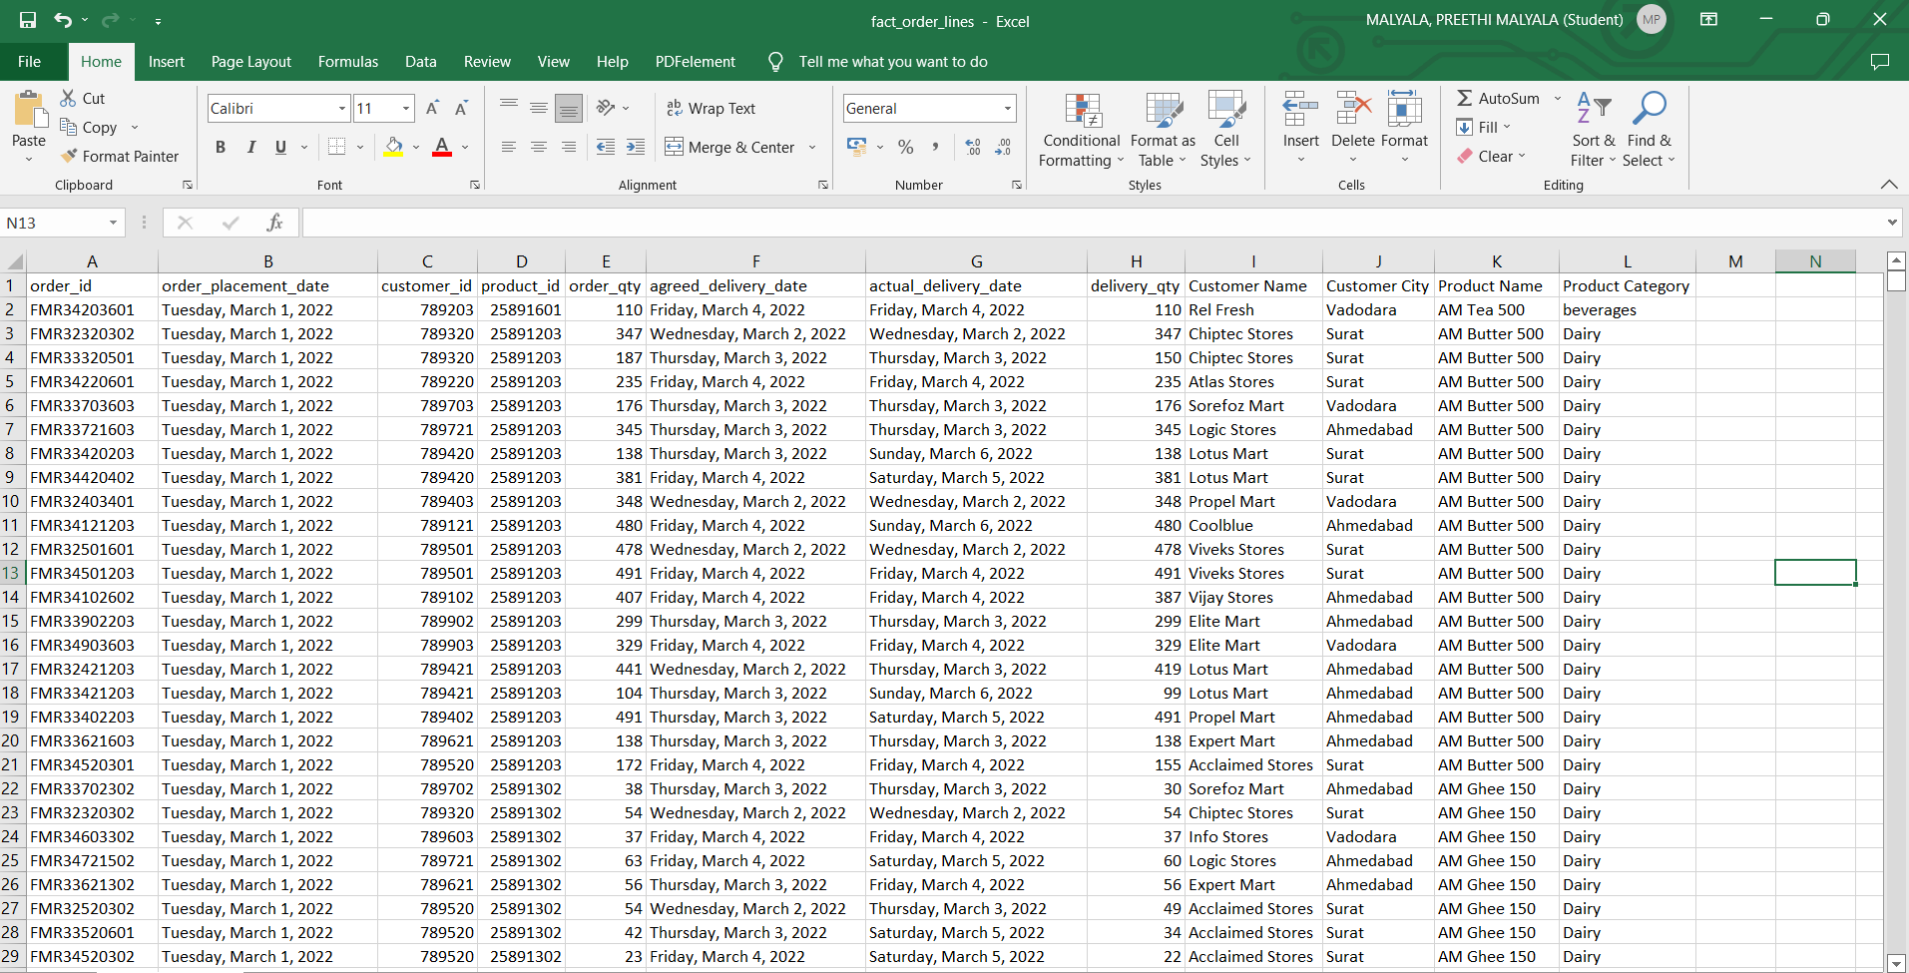

*Fig: orders line table data in excel*

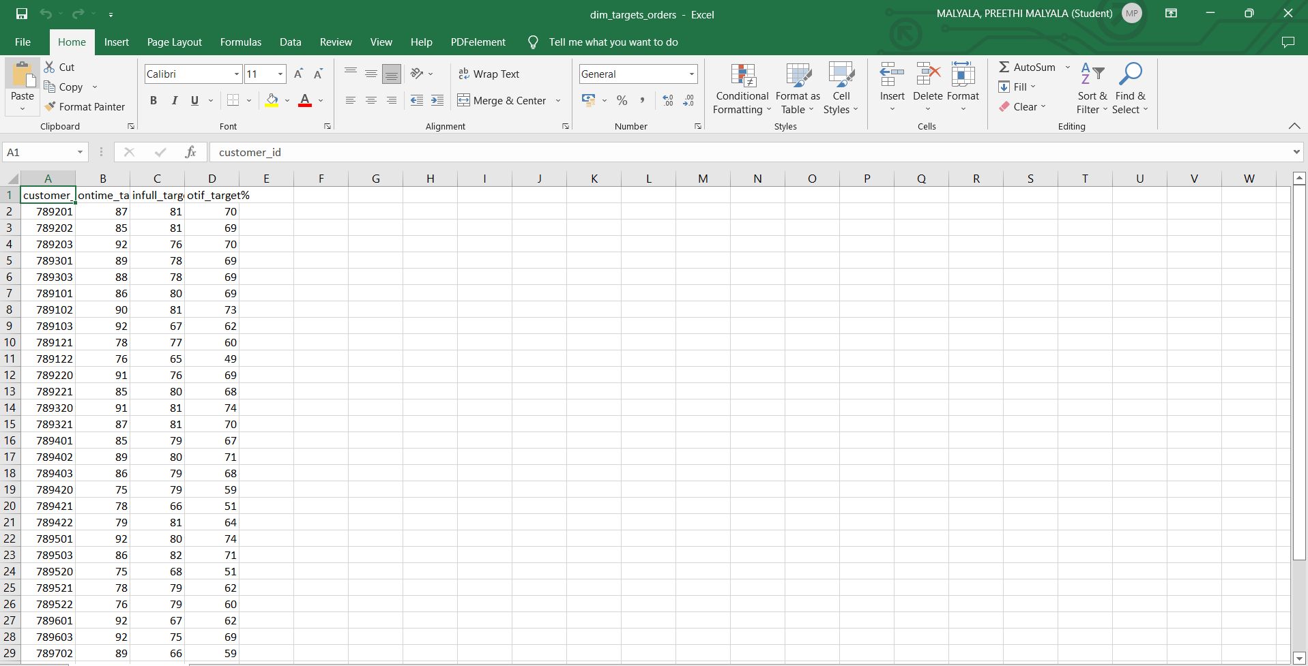

*Fig 2: target orders list table in excel*

### Outline of Business Questions:

This PowerBi project mainly aims at the supply chain analysis of the AtliQ company. This Analysis is going to answer the following questions.

* What is the average of orders delayed from the agreed date?
* Which store has the highest delayed orders?
* Which products have been delayed the highest and what is the highest product quantity delayed?
* Are there any noticeable trends?
* Which city has the highest performance and which city does not?
* Which customers are achieving targets?

### KEY FINDINGS and INSIGHTS:

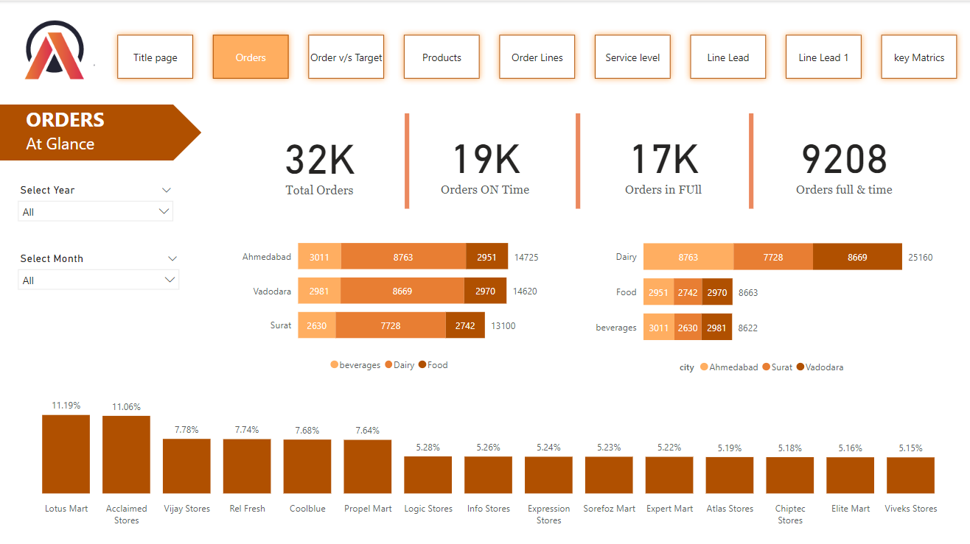

* **Dairy products** orders are almost double that of the Food and Beverages category.
* First 6 Customers Acclaimed Stores, Lotus Mart, Vijay Stores, RelFresh, Cool Blue & Propel Mart constitutes 53% of Total orders & seems to be key customers.
* Used 2 bar graphs that depict the Orders based on Categories in different cities and the Orders based on cities in different categories.
* The last bar graph shows the cities with the highest order count to Lowest.



* As we see in the above slide only 59.03% of total orders are delivered on time
* Average OT%, IF%, and OTIF% are noticeably lower than the Targeted levels.
* The gauge axis is used to show the actual OT, IF and OTIF values with the respected target values.
* A card is used to show the difference between the actual and Target values.
* The bar graphs show the difference between OT, IF and OTIF values with the target values based on cities.

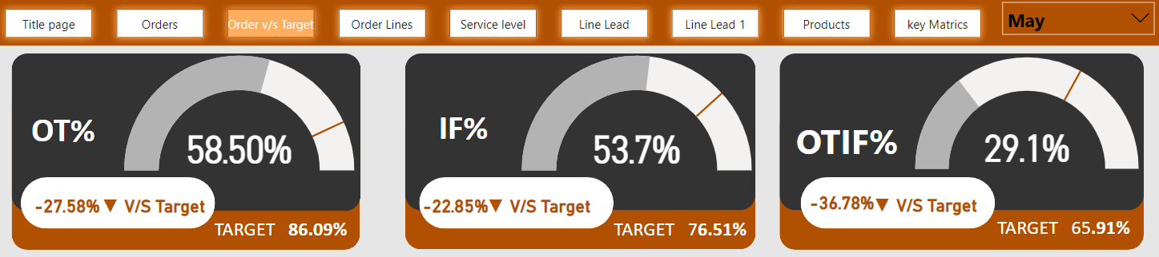

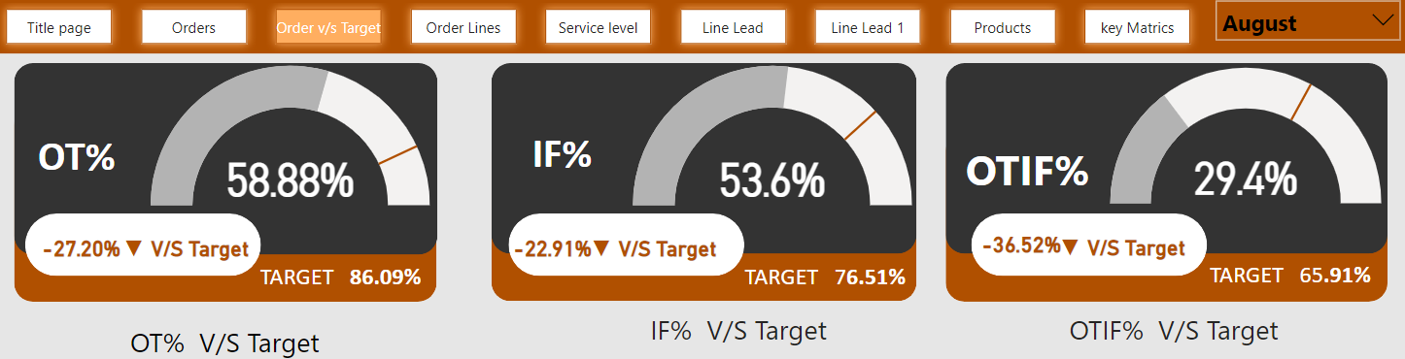

* **MAY’22**and **AUG’22** are the two months where **IF%** and **OTIF %** have shown slight improvement compared to the past month, still they are far away from Target levels

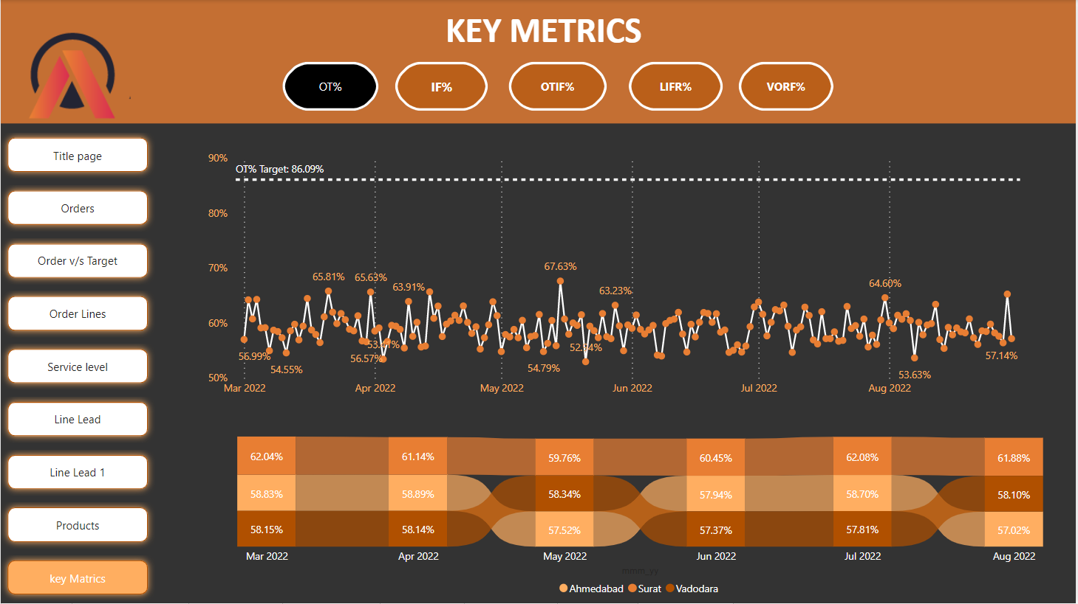

* When the **Daily Trend for OT%** is plottedfor Order using **Line Chart**, the difference in the OT% and the Target OT% is significantly high, which depicts that the On Time Delivery Percentage of orders is very delayed.

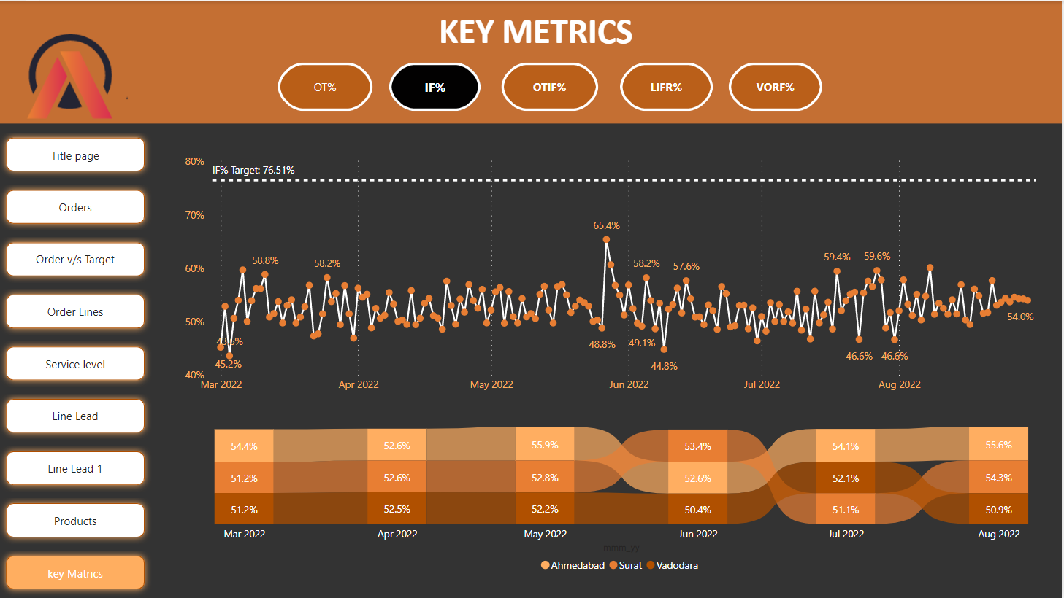

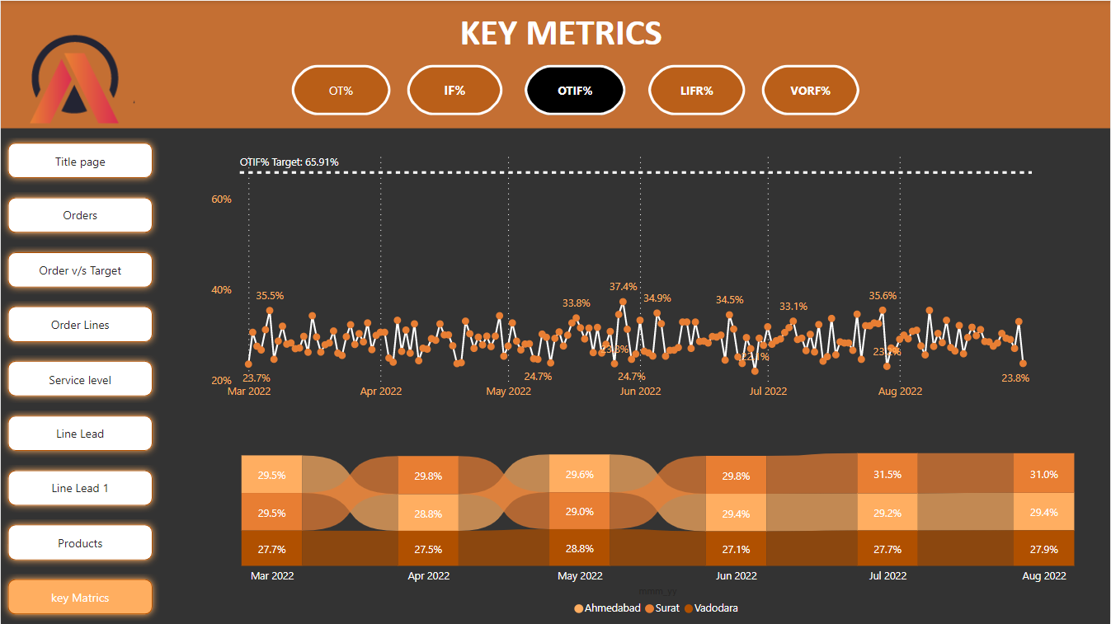

* Even the Daily trends of the **IF%** and **OTIF % chart** shows that not a single day they are able to touch the Target lines for respective matrices.
* Especially **OTIF% performance is quite disappointing.**



* Service Level Analysis of Orders shows **Acclaimed Stores, Cool Blue & Lotus Mart** have noticeably lower OT% and OTIF % even their IF% too are also not so much convincing.

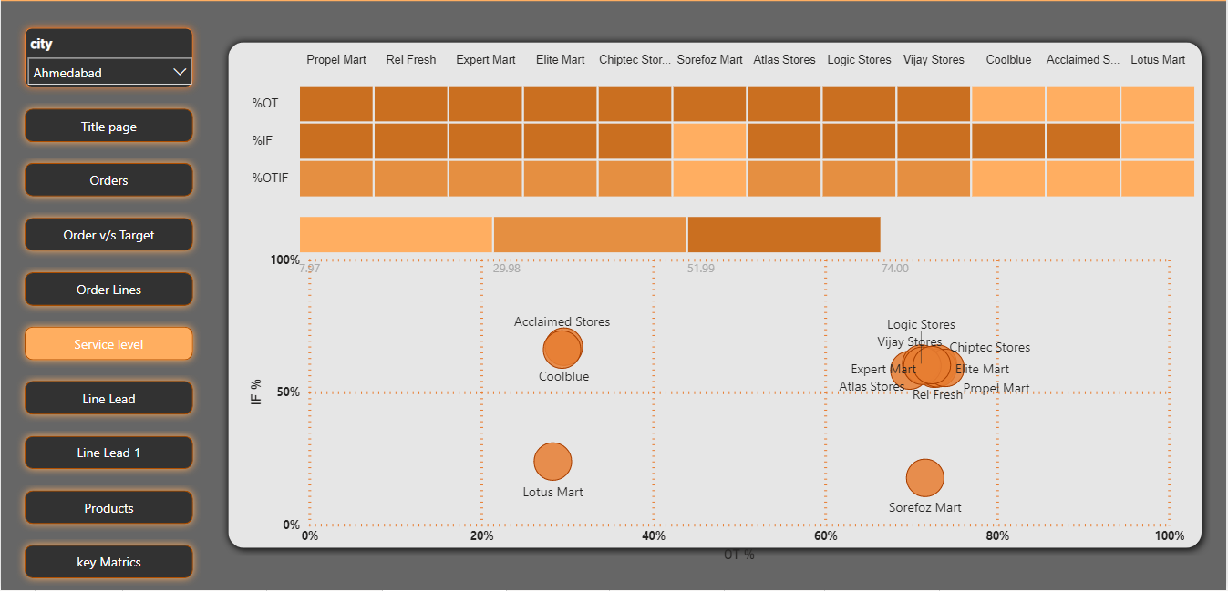

* When service levels are filtered for **AHMEDABAD** city it brings to our notice one more alarming insight that **IF% & OTIF % level** for **Sorefoz Mart** are severely low, which needs to be taken care.

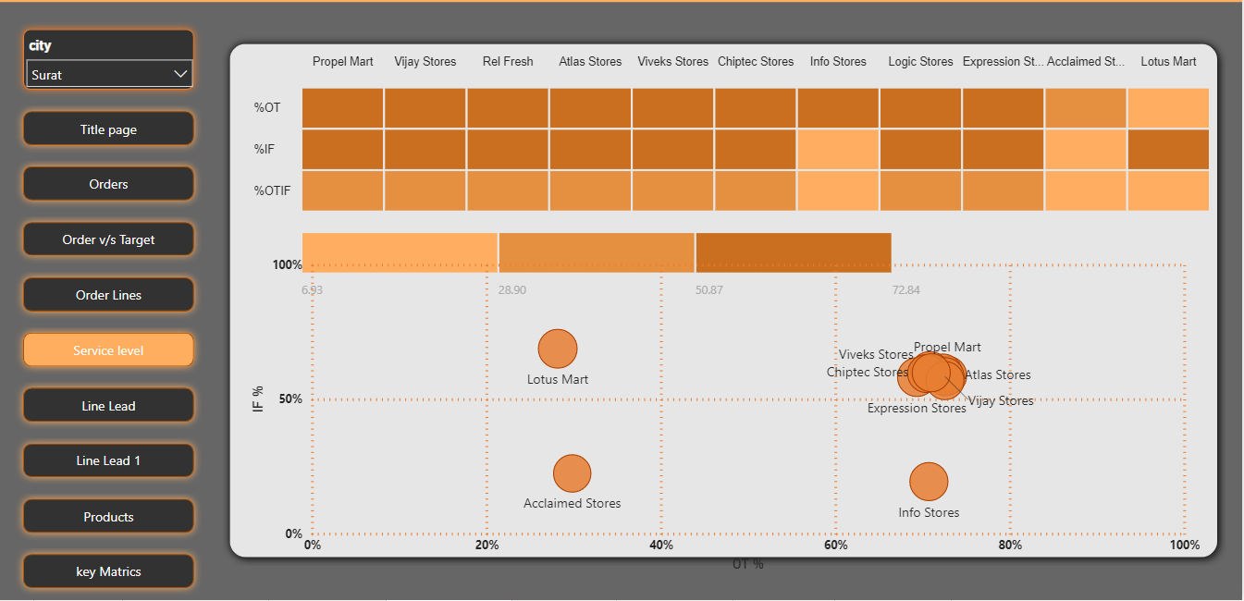

* When service levels are filtered for **SURAT** city Info Stores shows alarming **IF% & OTIF** % levels.

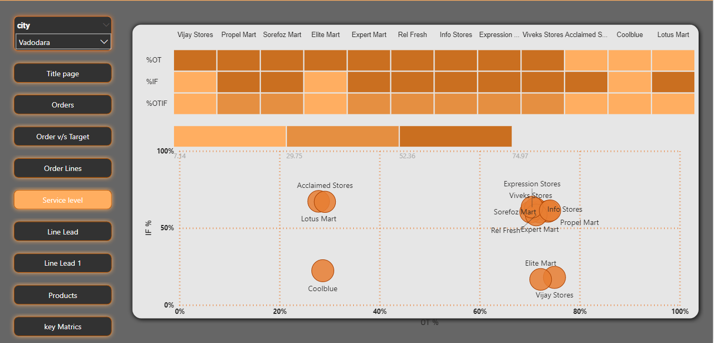

* For **BARODA** **city** **Elite Mart & Vijay Stores’** IF% & OTIF % levels are giving alarming signals.
* All these alarming levels of IF % and OTIF % show that distribution centres are running out of stock very quickly and replenishments must be optimized to improve.

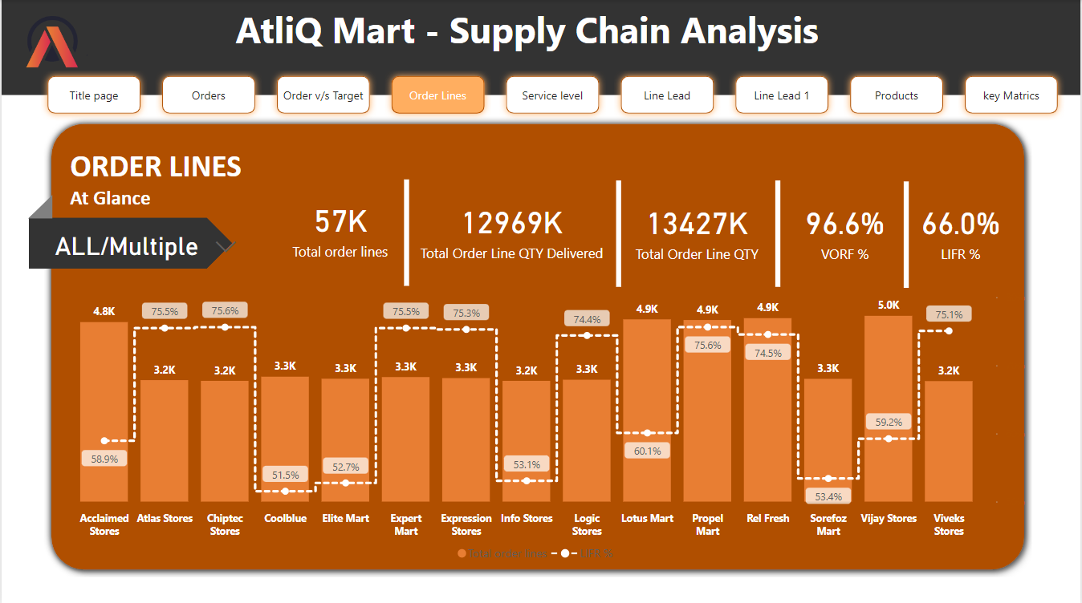

* Initial analysis of the Order Line overview shows that there are certain customers that have **LIFR %** noticeably lower than the Average **LIFR%**.
* Acclaimed Stores, Cool Blue, Elite Mart, Info Stores, Lotus Mart, stores Mart & Vijay Stores
* Out of The **Acclaimed Stores, Lotus Mart & Vijay Stores** are the customers who have larger no. of order lines amongst all.
* The Line and Clustered column chart here show customer_name on X-axis, Total order lines on Y-axis and LIFR on Line Y-axis.

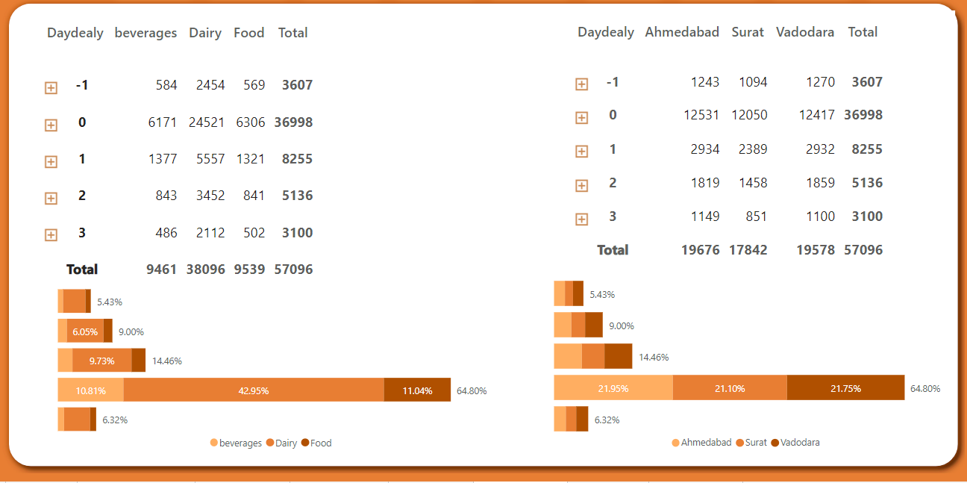

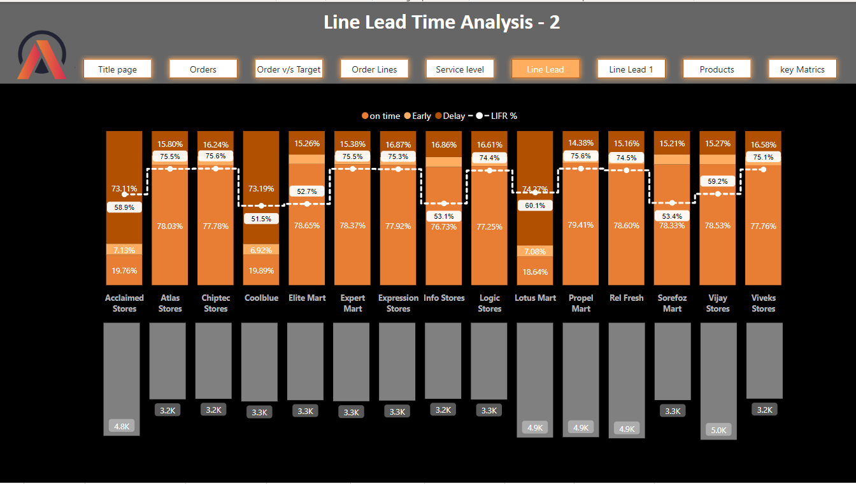

Further detailed analysis of Line lead time analysis combined with delayed days analysis reveals some interesting facts.

### Conclusions and Recommendations:

Unfortunately, **Acclaimed Stores, Cool Blue & Lotus Mart** are the Key customers who would certainly not be willing to renew the contract as more than 75% of order lines are being delivered late and they are having the highest number of orders. Moreover, out of that **75%** delayed deliveries, **66%** of them are late by 2 or 3 days. The average **OTIF% is significantly lower than the Targeted OTIF %** Which shows poor delivering capabilities.

Hence my recommendation for the AtliQ company is to focus on delivery management as delay in deliveries is the key hindrance to business development and retaining the customers.

# **ICA Appendix-BA Design**

# **Data Pre-Processing and Data Cleaning:**

### **Data Loading:**

The first step of data pre-processing is importing data. So, to Import data click on Get data on the PowerBi desktop. Since I already have existing excel data, I have not created a Blank query using M language to create Data that’s another option to get data loaded in PowerBi Tool.

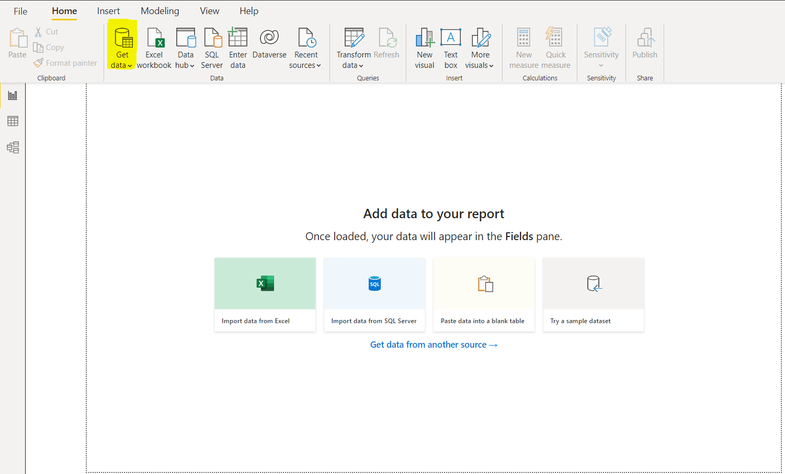

*Fig 2: Screenshot to Get Data*

To pull in data click on “**Get Data**” on Desktop Menu.

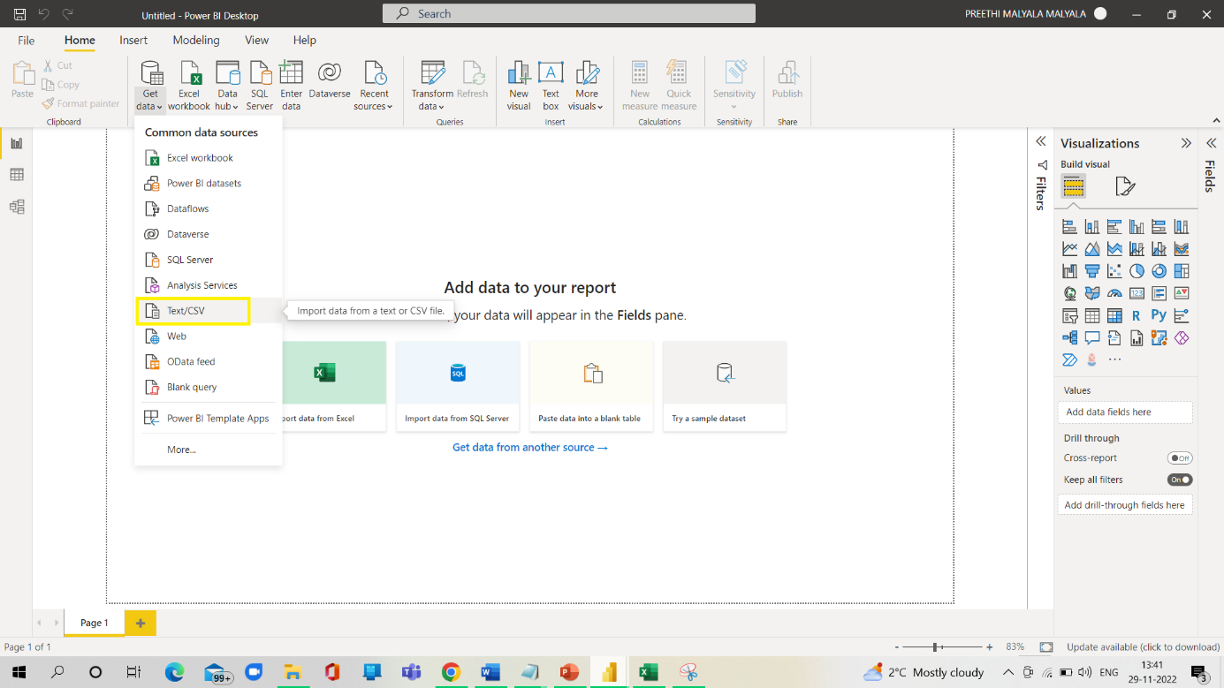

*Fig 3: Choosing the data type*

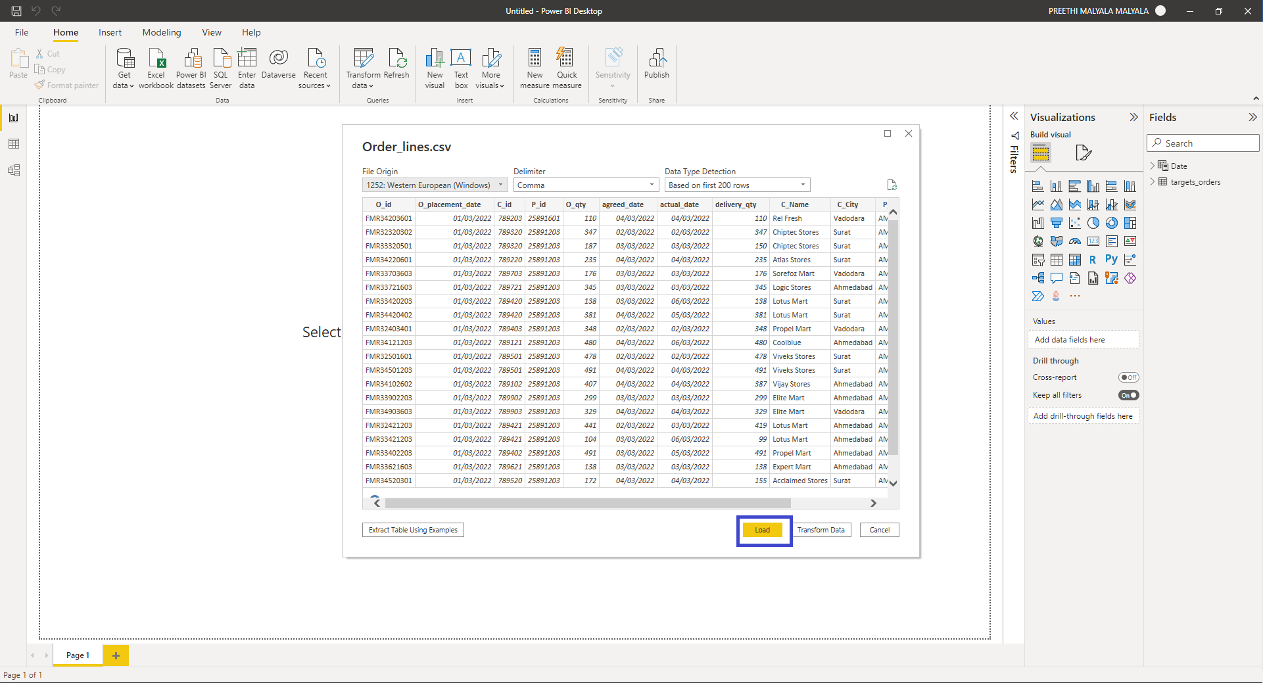

*Fig 4: Load data dialog box*

The same process was followed by the Targets table as well, Once the data is loaded you will see all the fields of the loaded data available in the Fields Section of the Power BI Desktop as highlighted below in the Fig (5). In the below screenshot, we can see the two tables loaded successfully.

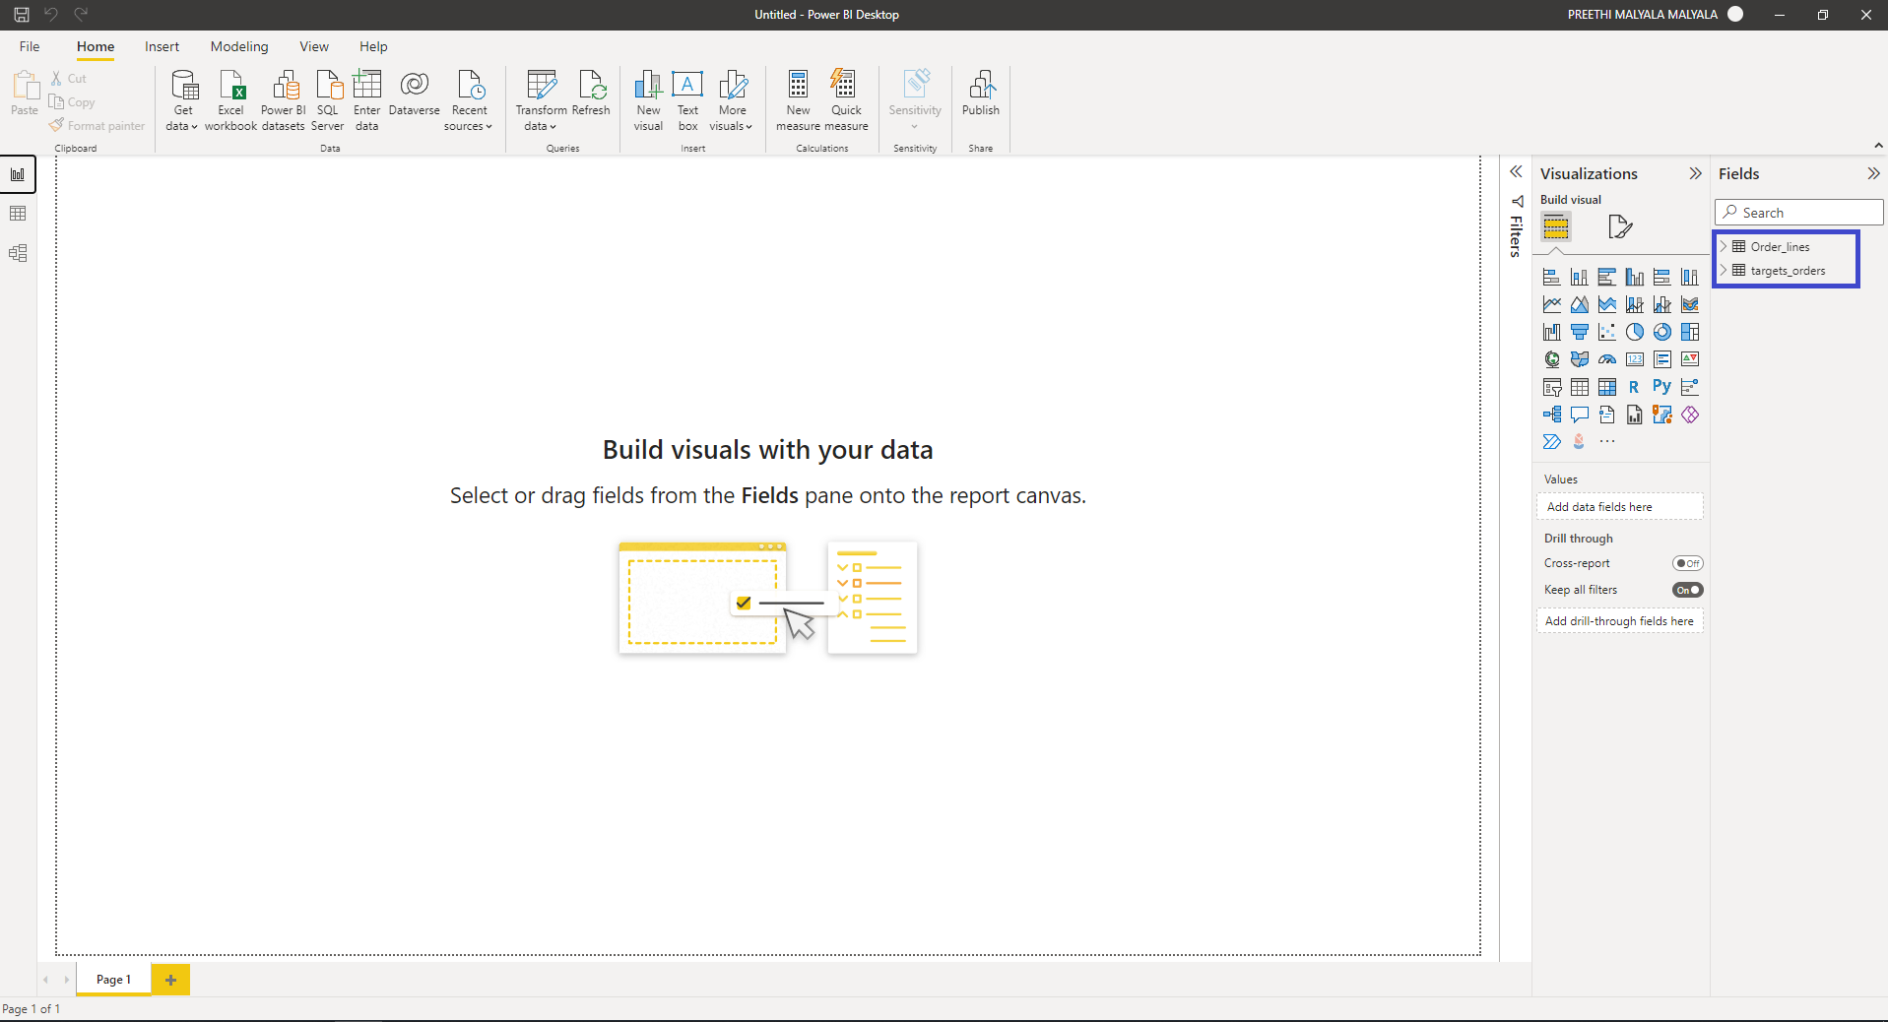

*Fig 5: Two tables successfully loaded in PowerBi*

**Data Cleaning**  
  
Cleaning the data by clicking on the “**Transform** **data**” in the top view.

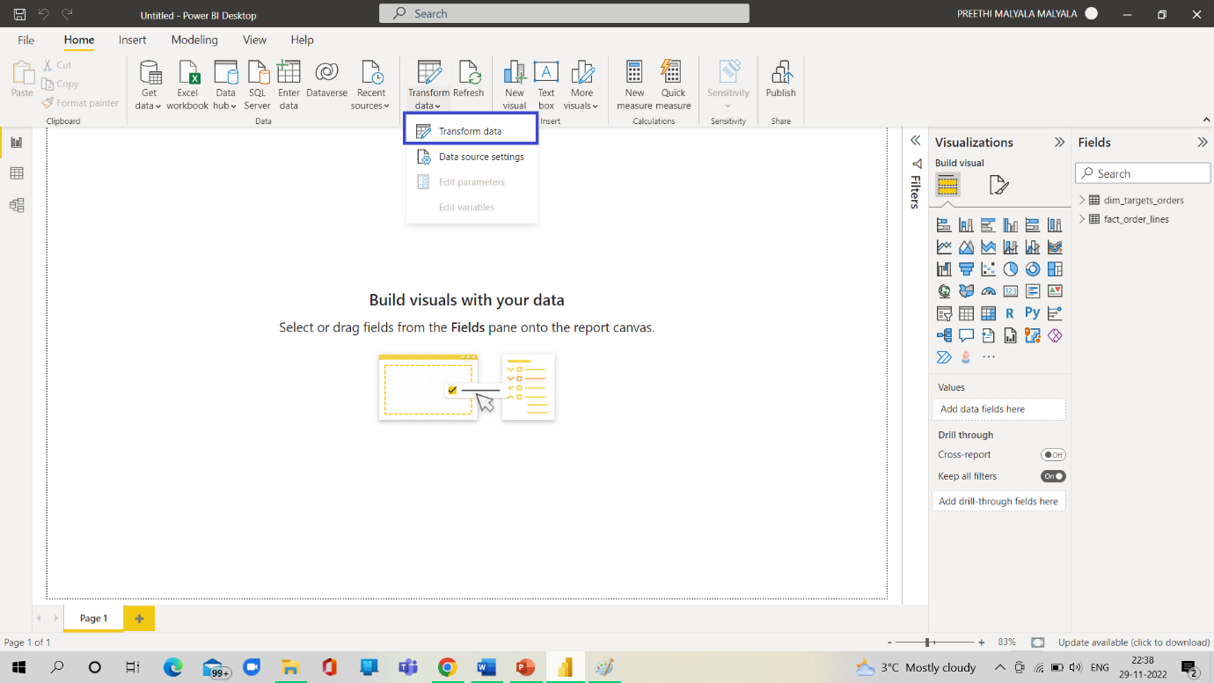

*Fig 6: Click on Transform data*

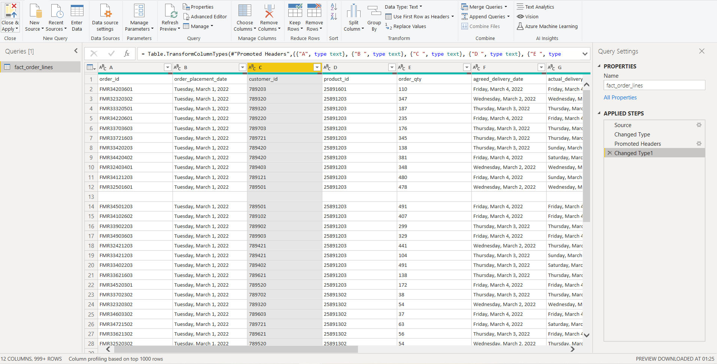 *Fig 7: Power query editor is opened*

### First Row as Header:

As shown in fig (7) the header is one of the rows in the dataset to change it as the header in the power query editor choose the “**Use first row as headers**” option. As shown in fig(8) the first row is changed into a header.

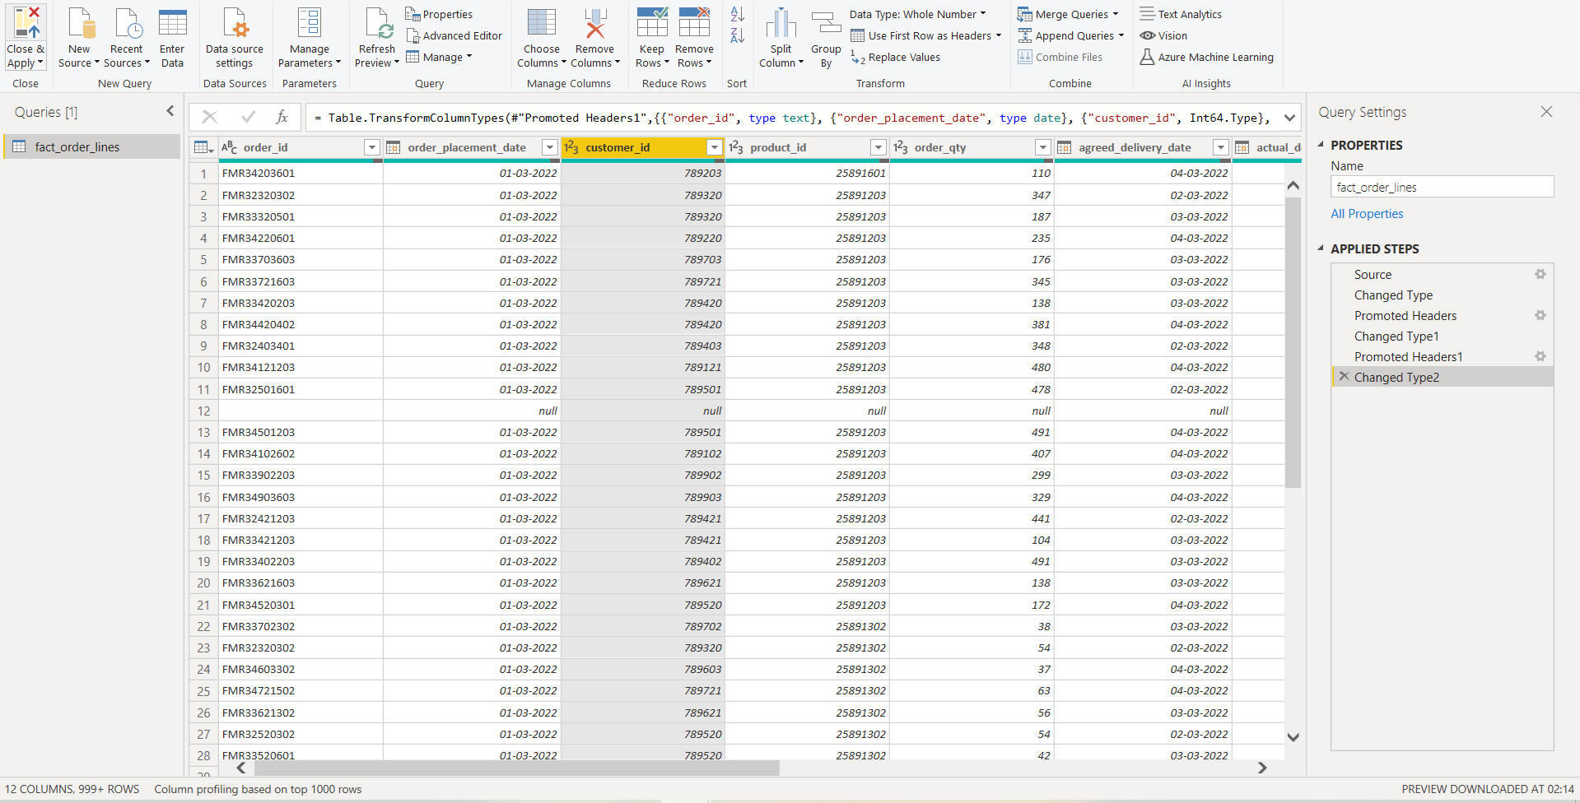

*Fig 8: First row as header*

### Removing Null Values:

To remove null values the process followed is in the power query editor chosen in the Order_lines table which has null values. Selected the remove blank rows option when right click on the dataset. Found few null values in the data as null values can be seen in the above fig(7). Below is the Screenshot of the table after removing Null values from the data.

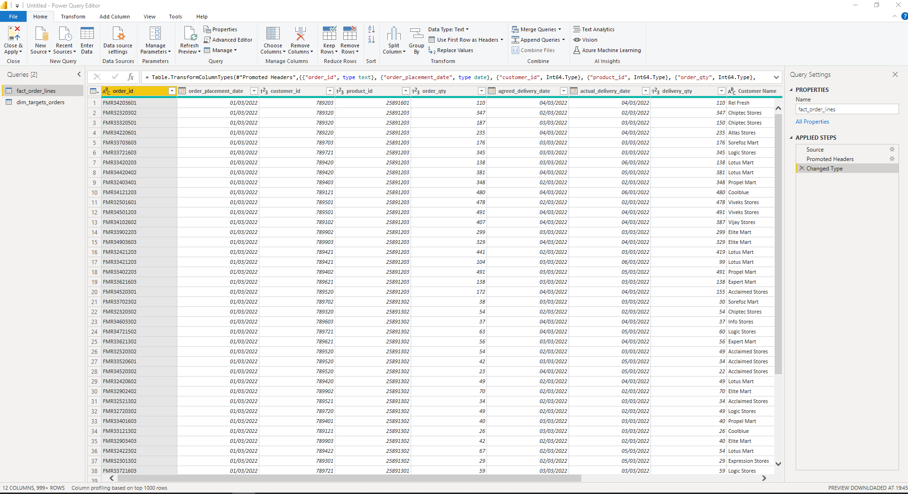  
 *Fig 8: Screenshot after removing the null values*

### Renaming Columns:

To not get confused with column names and identify them easily Change the column names as shown in the below table:

|  |  |
| --- | --- |
| **Old Column Name** | **New Column Name** |
| O_id | Order_id |
| O_placement_date | Order_placement_date, |
| C_id | Customer_id |
| P_id | Product_id |
| O_qty | Ordered_qty |
| agreed_date | Agreed_Delivery_Date |
| actual_date | Actual_Delivery_Date |
| C_Name | Customer_Name |
| C_City | Custome_City |
| P_Name | Product_Name |
| P_Category | Product_Category |

Below Fig(9) is the result after changing the column names

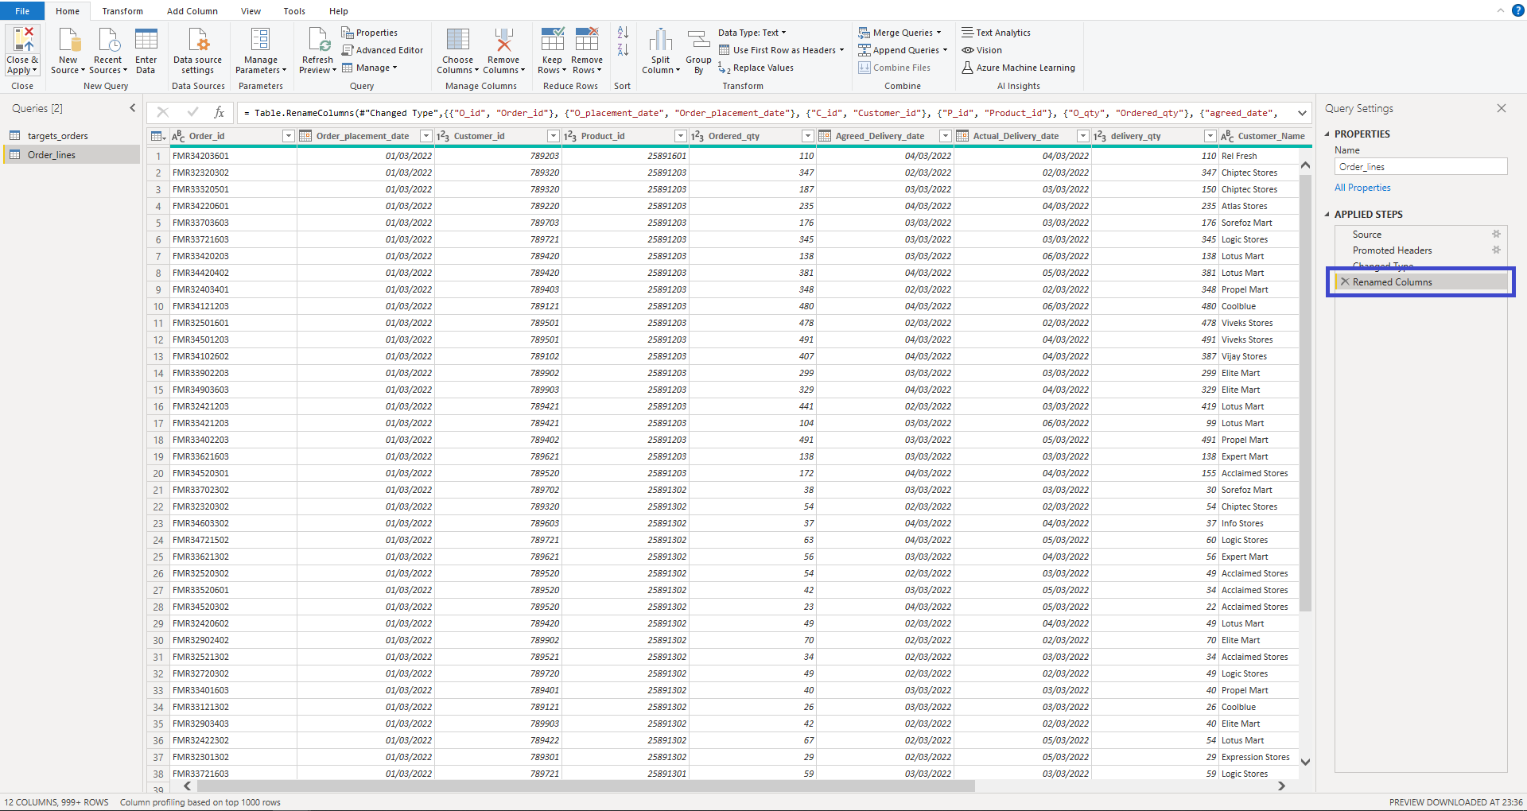  
 *Fig (9): Screenshot after renaming the columns*

Click on Close & Apply.

### Creating Tables in Power Query Editor:

Starting from the data above, I want to categorize the orders table into 4 tables.  
Customer Table  
Products Table  
Orders Aggregate  
Date Table.

#### **Customer’s table:**

1. Go to Report View
2. Click on “Transform Data”
3. Rt. Click on Order_lines table, then choose Duplicate where you can see a duplicate table is created like below.

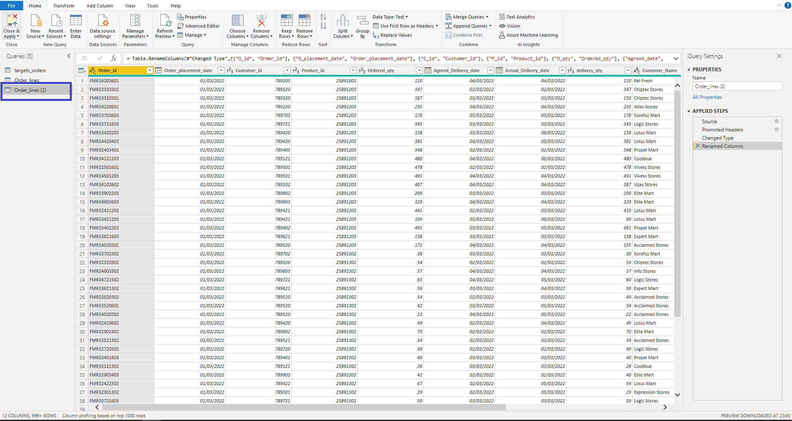Here For Customers Table the columns we needed from Order_lines table are Customer name, Customer City, and Customer Id. Then Click on “Choose Columns” then chosen the Columns mentioned above. The pop-up appears as we can see in the image below.

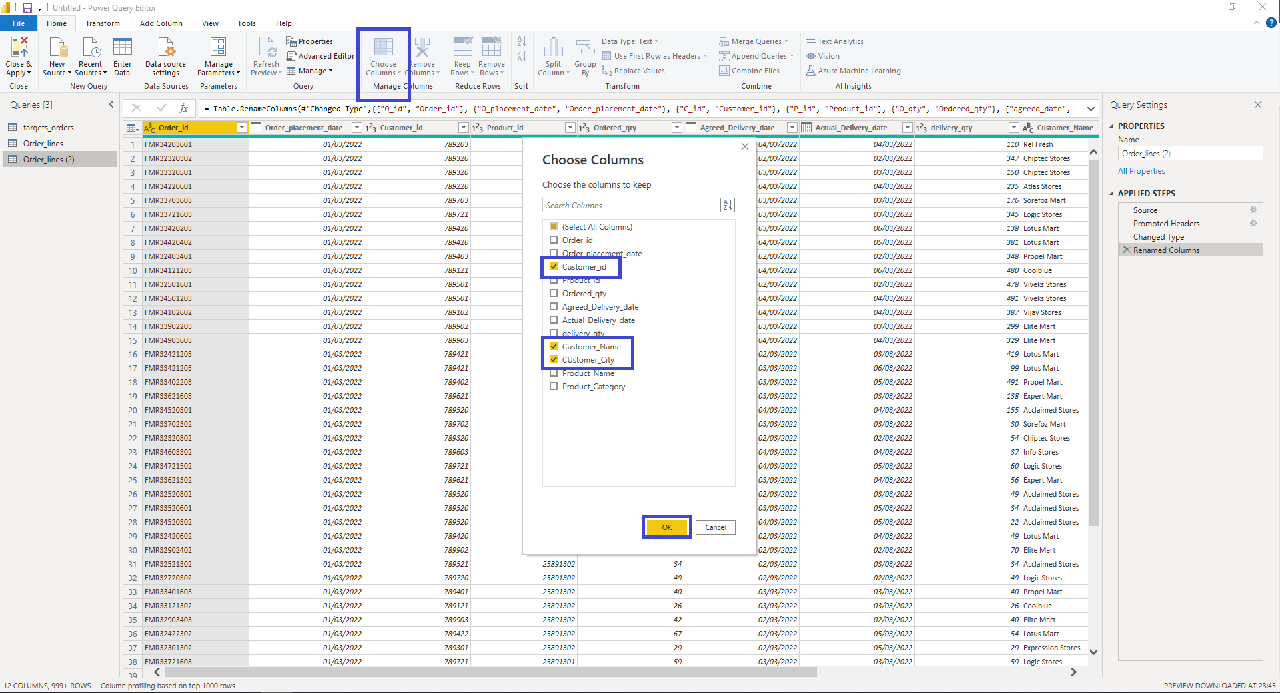

Click on “Ok”. Then the Table is created like below fig()

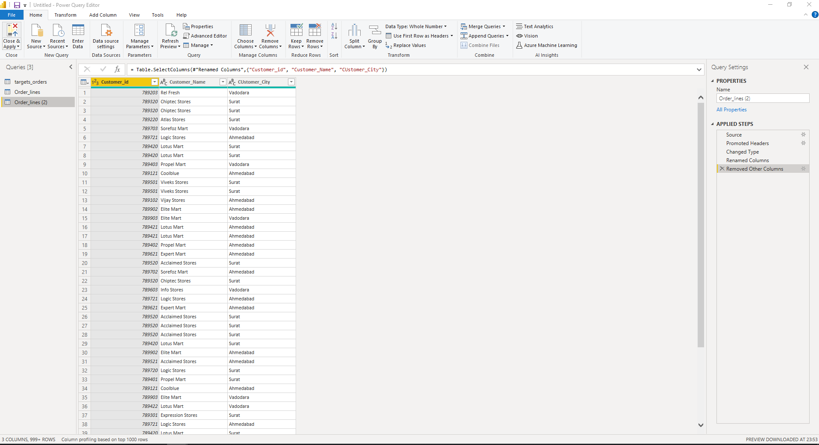

As we can see Customers table has been created but there are many duplicate values so on Customer_id column give a right click and choose “Remove Duplicates”. A final Table has been created as Shown Below and Rename the table as Customers.

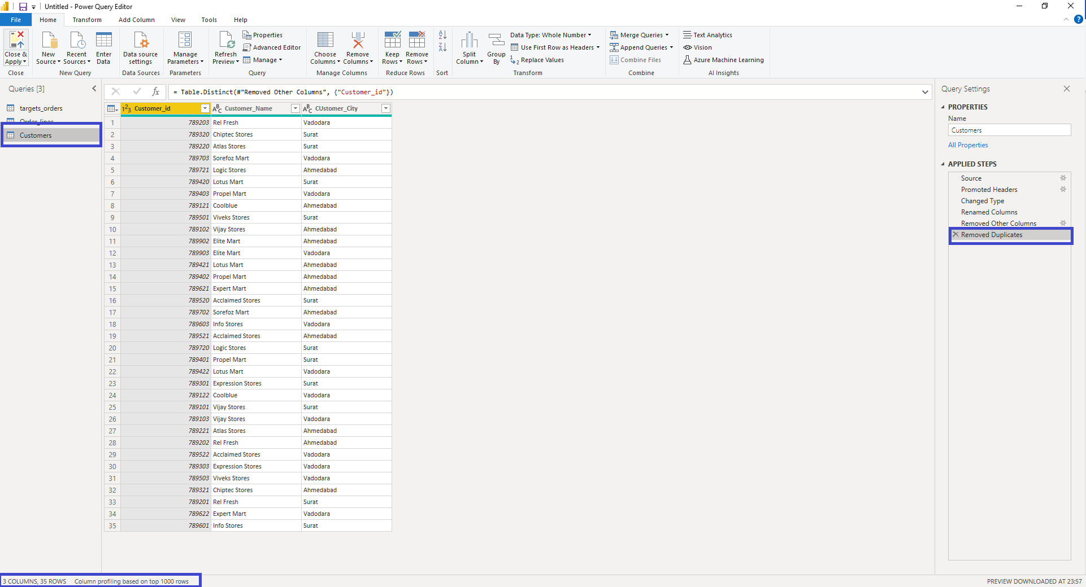

As shown in the above Fig() we can see the Customers table is created which Includes the Columns Customer ID, Customer City, and Customer name with 35 rows.

**Product Table:**

1. Go to Report View
2. Click on “Transform Data”
3. Right click on Order_lines table, then choose Duplicate where you can see a duplicate table is created like below. As explained in the Customers table Click on choose Columns and selected the columns Product_id, Product_name, and Product_Category.

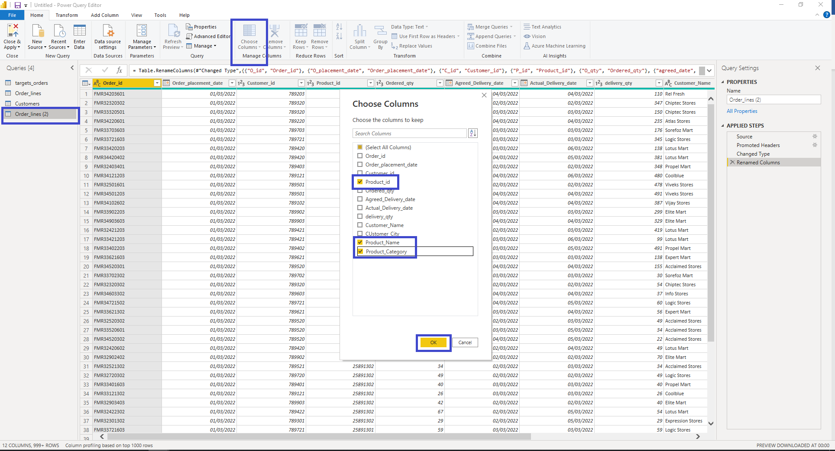

Then click on “**OK**” .As we can see Customers table has been created but there are many duplicate values so on Product_id column give a right click and choose “Remove Duplicates”. A final Table has been created as Shown Below and Rename the table as Products. As we can see in the below fig() the Final table has been created.

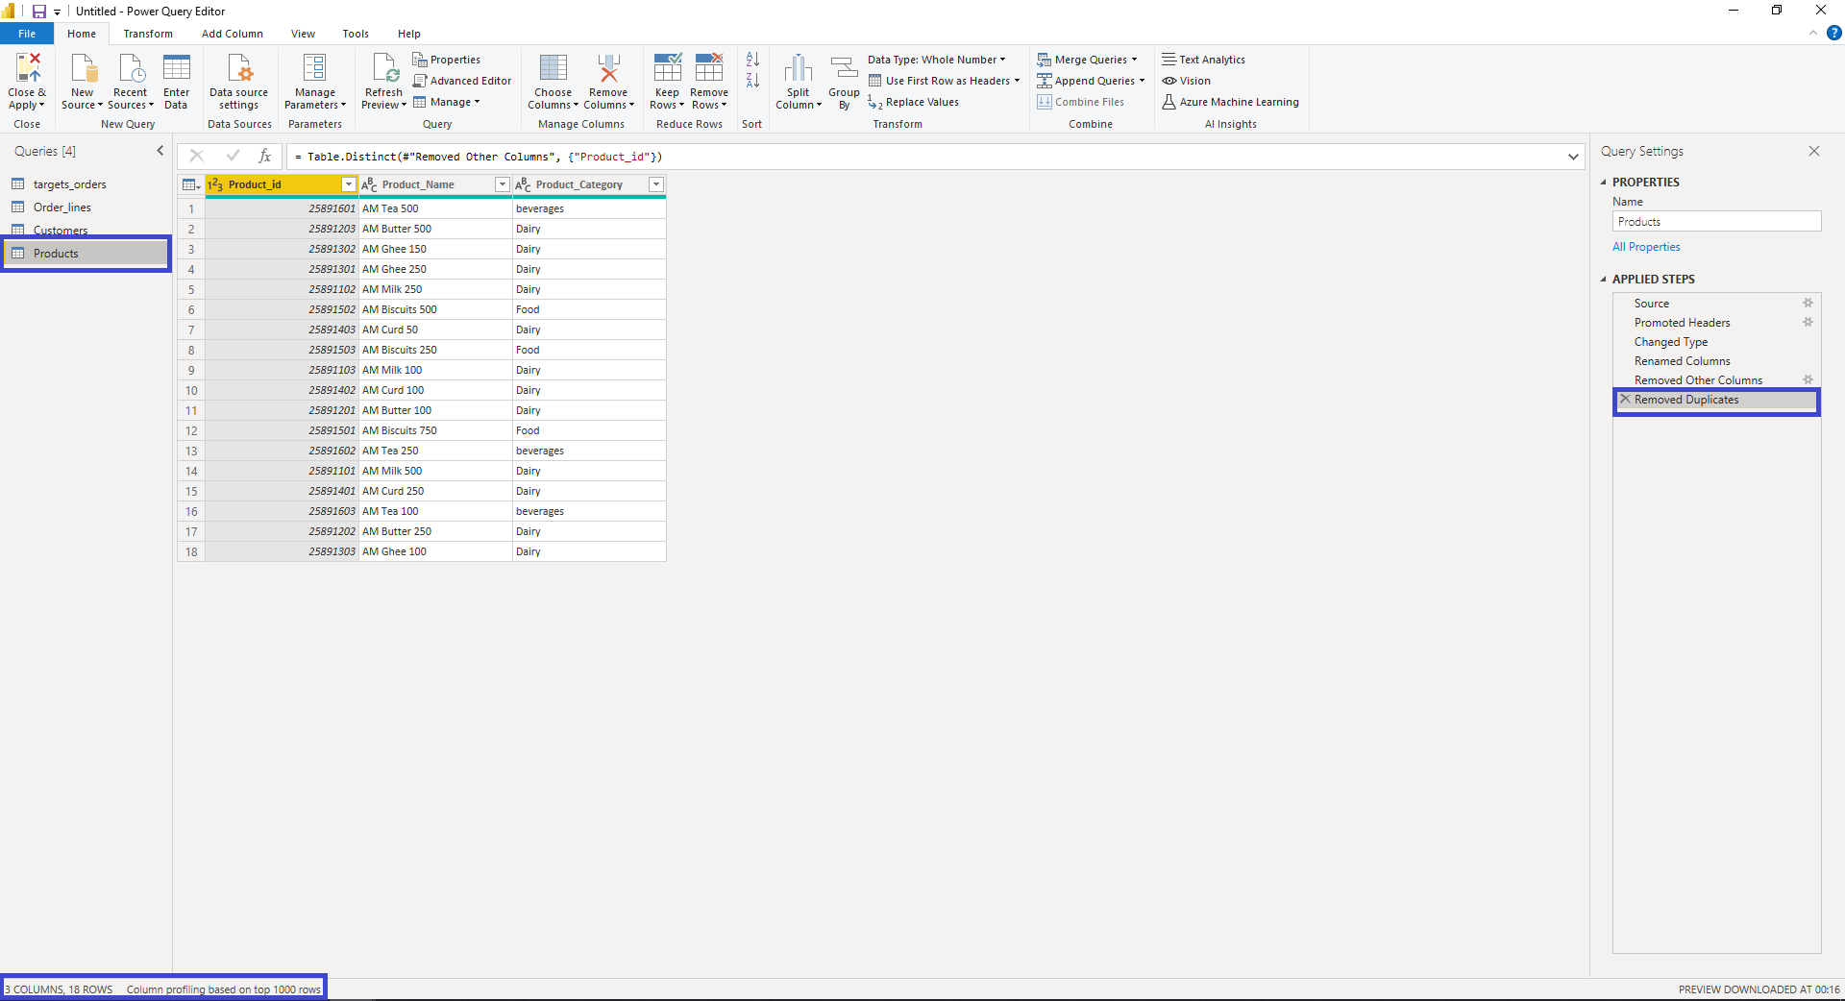

As you can see in the above Fig() the Product table has been created with 18 Rows. With the column Product_id, Product Name, Product Category.

#### **Creating Orders_Aggregate Table:**

1. Go to Data View
2. Click on “New Table”
3. Write DAX Formula: Here I am using SUMMARIZE function as I am creating a table from an existing table.
   1. Here For the Product Table the columns we needed from Fact_order Table are Product_id, Product_name and Product Category.

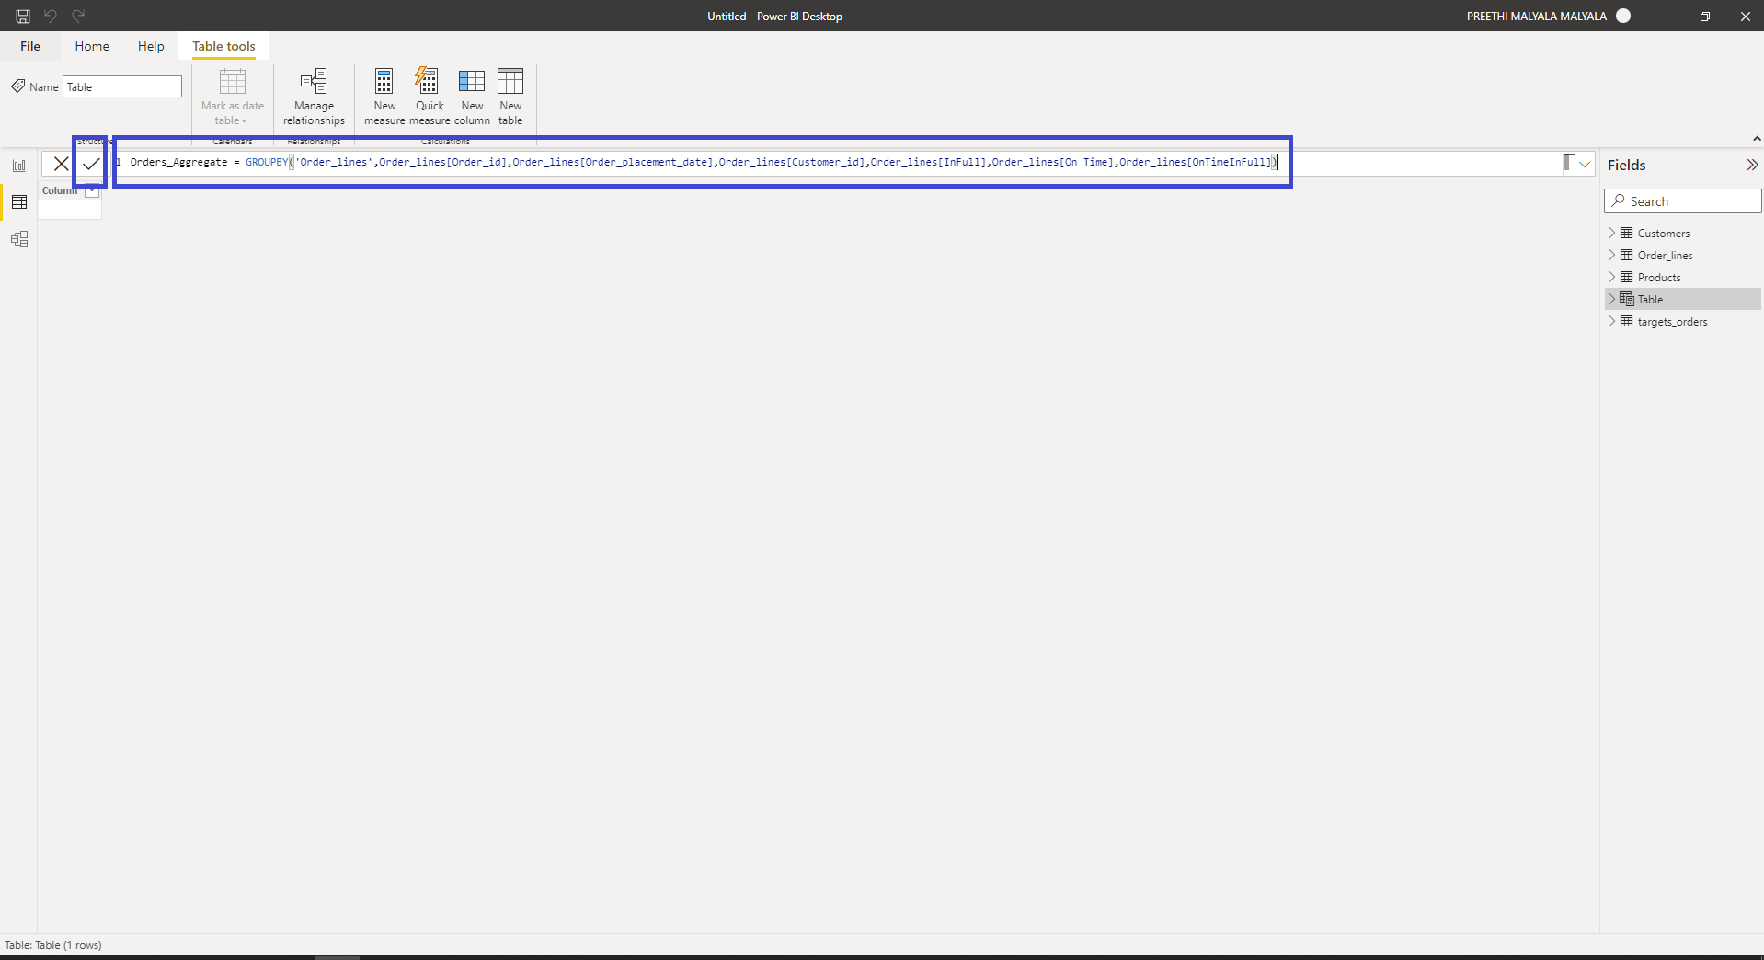

Click on Ok symbol then the below fig()  
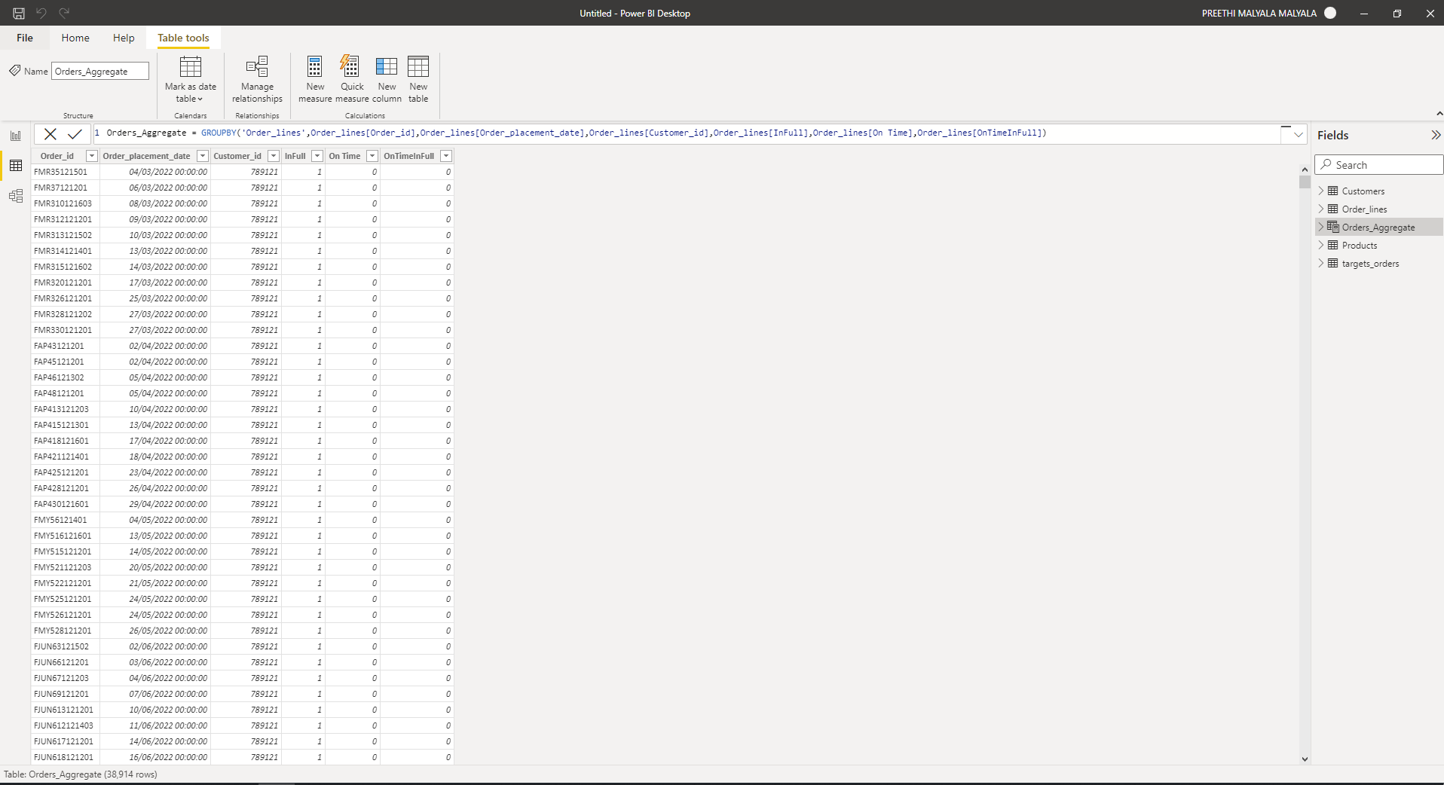

#### **Creating Date Table Using DAX:**

1. Go to Data View
2. Click on “New Table”.
3. Write DAX Formula: Creating a Date table with Columns of Date [01/03/2022-03/09/2022], Month and Week.

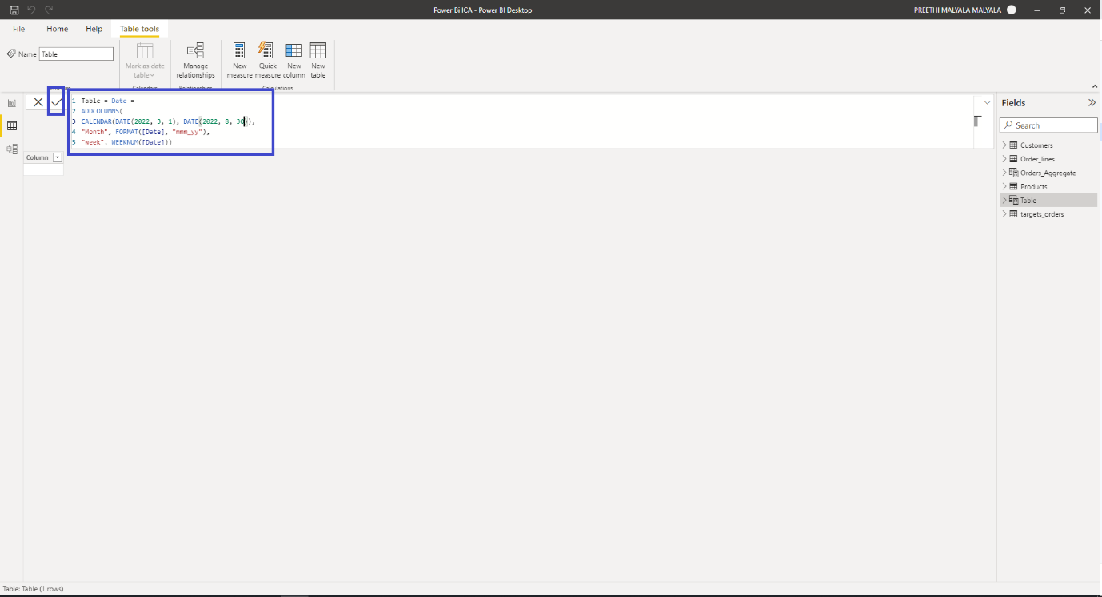

1. Click on the tick mark then the Date table is created, and Filtered data is shown like below

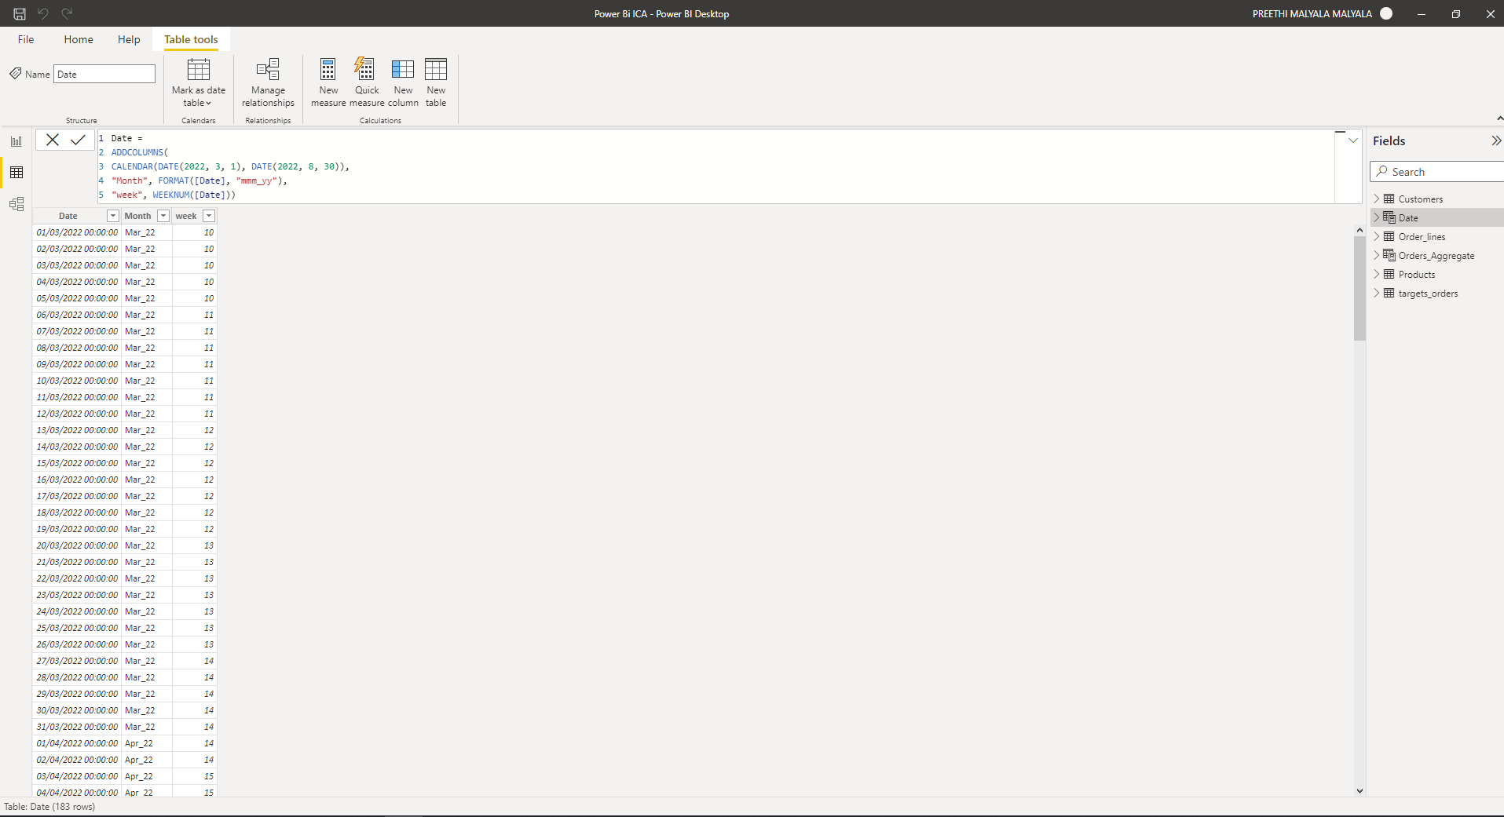

1. As you can see in the above Fig() the Date table has been created with 187 Rows. With the column Date, Month, Week.

### Removing Columns:

1. Go to Report View
2. Click on Transform Data.
3. Select the Columns to remove from the Order_line table they are Customer Name, Customer City, Product Name, and Product Category. Click **Ctrl+**Select the columns as shown in the below Image.

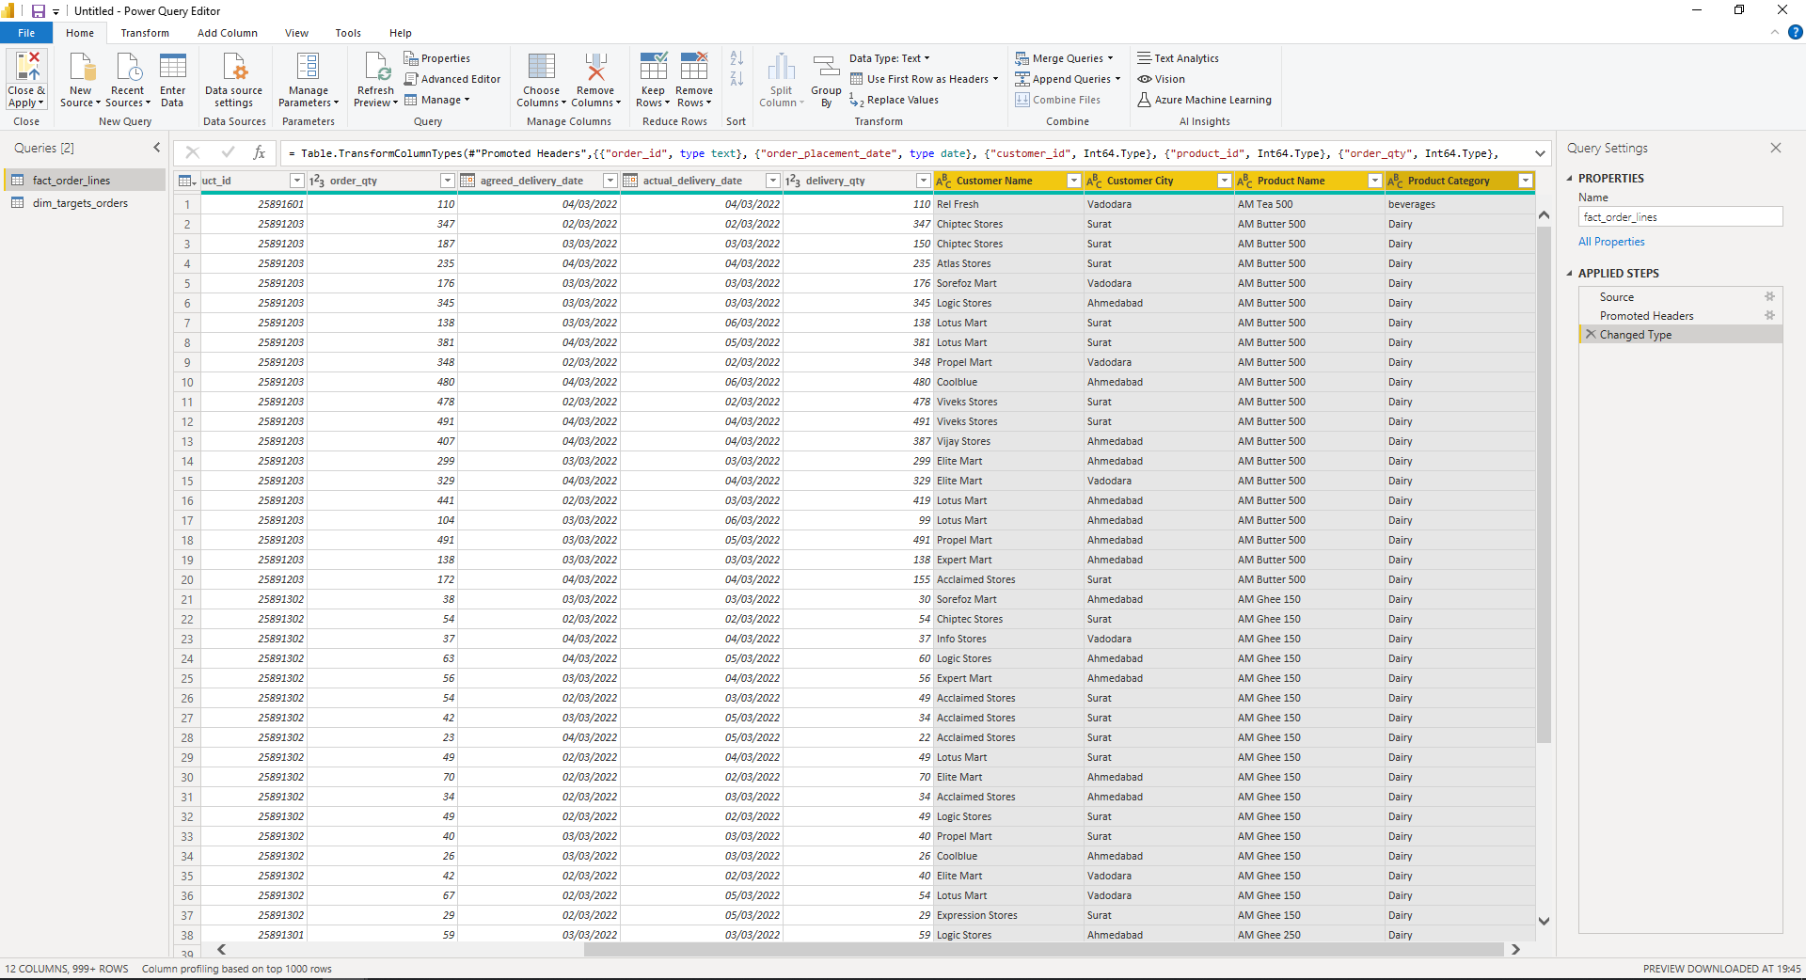

1. Give a right click where you can see the “Remove Columns” option Select it and the columns are removed now as shown in the below image.

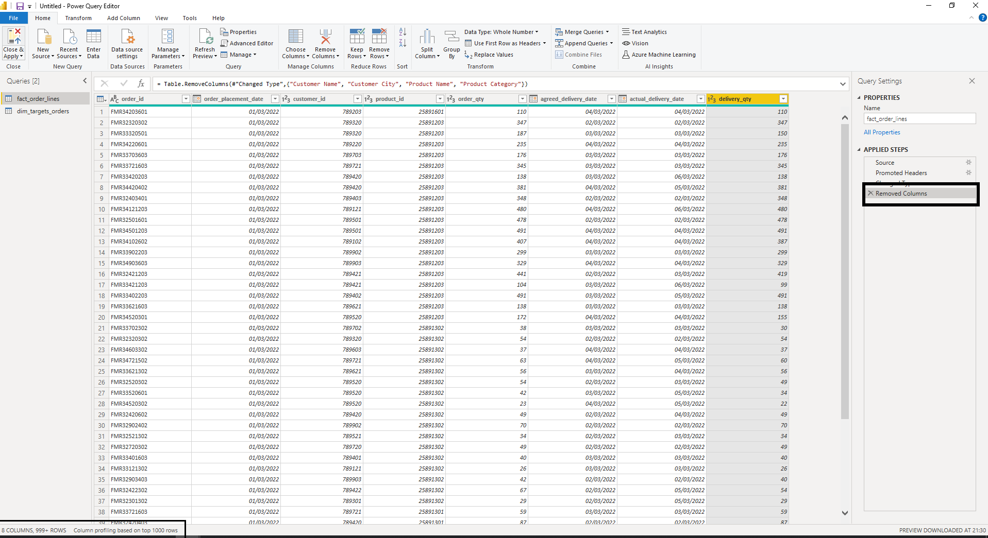

Now there are only 8 Columns in the Order_Line Table. Now Click on “**Close and Apply**”.

# **DATA MODELLING:**

Before creating the tables the data modelling the data looks like the fig shown below:

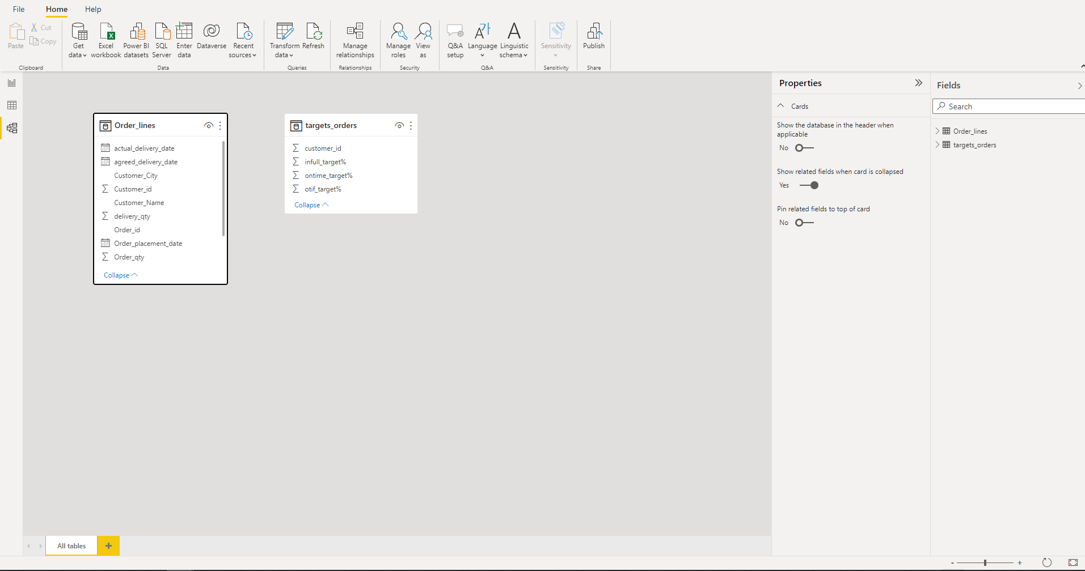

Now we have one big Order_lines table which is the fact table. Now we need to create dimensional tables to make the database understandable and simple.

**Fact Table**: In simpler words, this table contains the Metrics and Measures of our Business problems. Below mentioned are the 2 fact tables:

Now we have 2 fact tables whereas the Orders fact table is split into two tables and adding a prefix as Fact before the table name.

1. Fact_Order_lines
2. Fact_Orders_Aggregate.

**Dimensional Table:** this table provide context around facts.

Now we have created dimensional tables adding a Prefix as dim to the table name to avoid the confusion with other tables. They are

1. dim_customers
2. dim_products
3. dim_target_orders
4. dim_date

Now after all the tables have been created below fig shows the data model before the relationships are created.

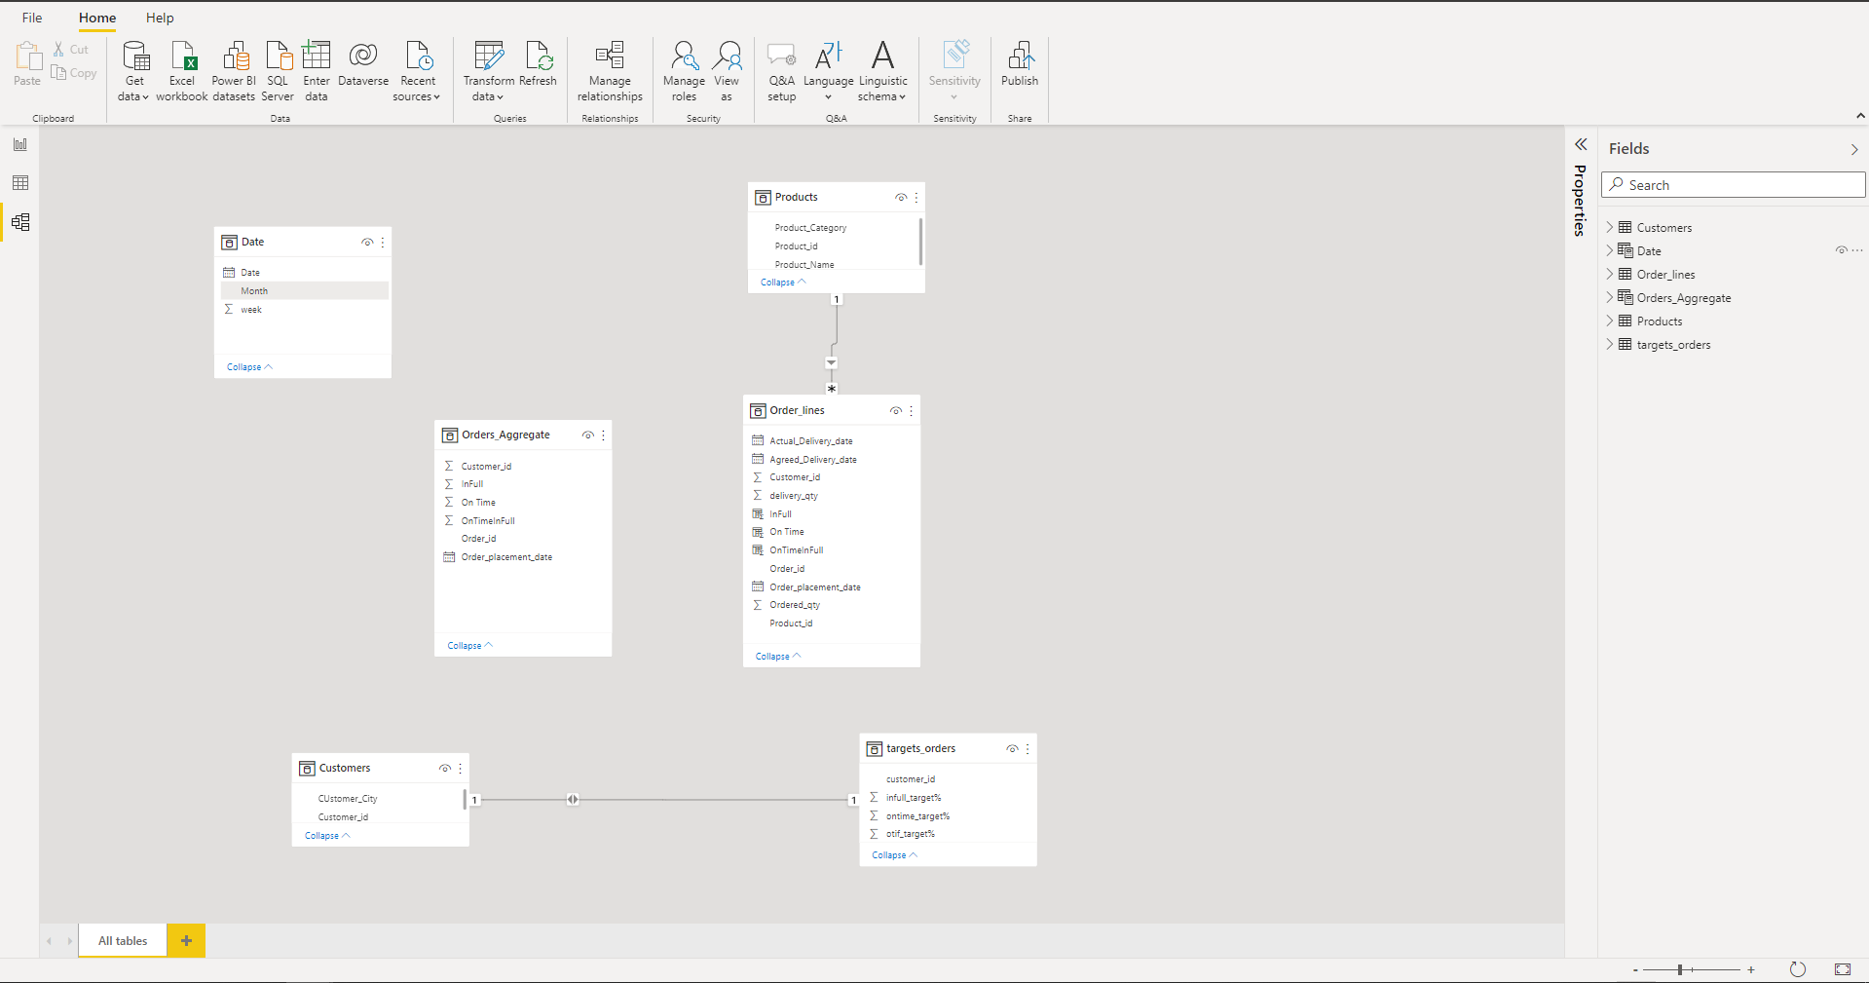

*Fig : Data Model before the relationships are created*

* Fact_Orders_Aggregate contains the header-level information of the orders.
* Fact_Order_lines contain in-detail information about the order and products.

|  |  |  |
| --- | --- | --- |
| **S.no** | **Fact table (Order_lines)** | **Dimensional table** |
| 1. | Product_id | Product_id(Product table) |
| 2. | Customer_id | Customer_id(target_orders) |
| 3. | Customer_id | Customer_id (customer table) |
| 4. | Order_placement_date | date (date) |

|  |  |  |
| --- | --- | --- |
| **S.no** | **Fact table (Order_Aggregate)** | **Dimensional table** |
| 1. | Customer_id | Customer_id(target_orders) |
| 2. | Customer_id | Customer_id (customer table) |
| 3. | Order_placement_date | date (date) |

|  |  |  |
| --- | --- | --- |
| **S.no** | **Fact table (Order_Aggregate)** | **Fact table (Order_lines)** |
| 1. | Order_id | Order_id |

|  |  |  |
| --- | --- | --- |
| **S.no** | **Dimensional table(customer** | **Dimensional table** |
| 1. | Order_id | Order_id |

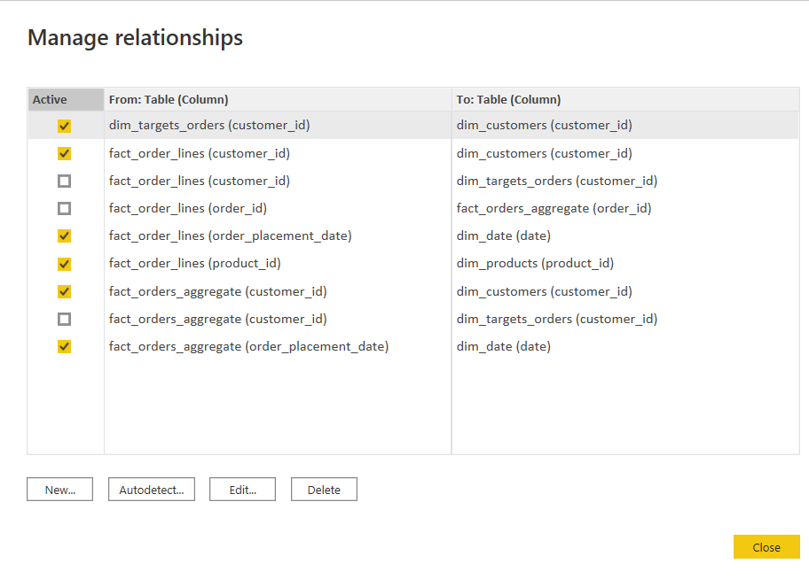

*Fig: Managing the relationships*

**Star Scheme:**

From the below Image we can clearly see the relationship model is Star Scheme whereas all the dimensional tables are connected to the Fact tables. By maintaining the Fact tables in the centre and dimensional tables opposite settled away in the corner from Fact tables clearly depicts it as Star Scheme.

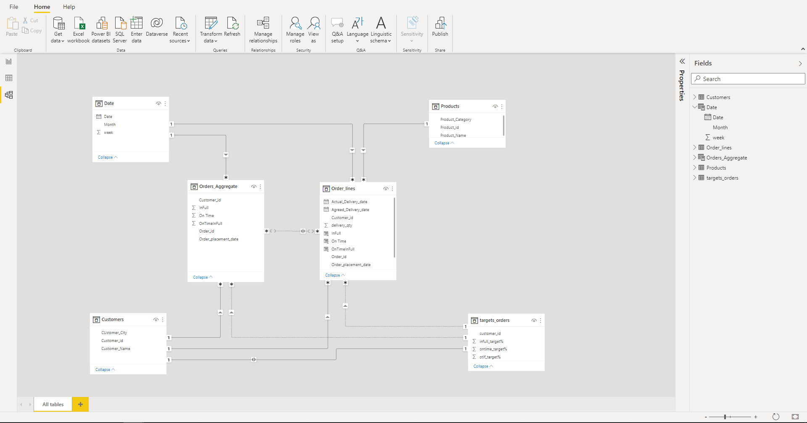

# **DAX Measures and Calculated Columns:**

**Calculated Columns:**

The below mentioned columns were created using DAX formulae from the columns of table Order_lines.

|  |  |  |  |  |
| --- | --- | --- | --- | --- |
| Sno | Measures | Abbreviation | Description | Table |
| 1. | Total Order Lines |  | Count of all order lines in Order_lines | Order_lines |
| 2. | On-Time Delivery | OT | No. of orders delivered On Time/ Total no. of Orders. | Order_lines |
| 3. | In Full Delivery | IF | No. of orders delivered in Full quantity/ Total no. of Orders | Order_lines |
| 4. | On-Time in Full | OTIF | No. of orders delivered both IN Full & On Time/ Total no. of Orders. | Order_lines |

**OT:**

Creating a calculated column in Fact_Order_lines table to find out on-time deliveries count. This makes lot easier to compare the Agreed delivery date and Actual delivery date and can also compare the delayed days count. Column has been created by using the below DAX function.

OnTime = IF

('Orders Table'[agreed_delivery_date]=='Orders Table'[actual_delivery_date],1,0)

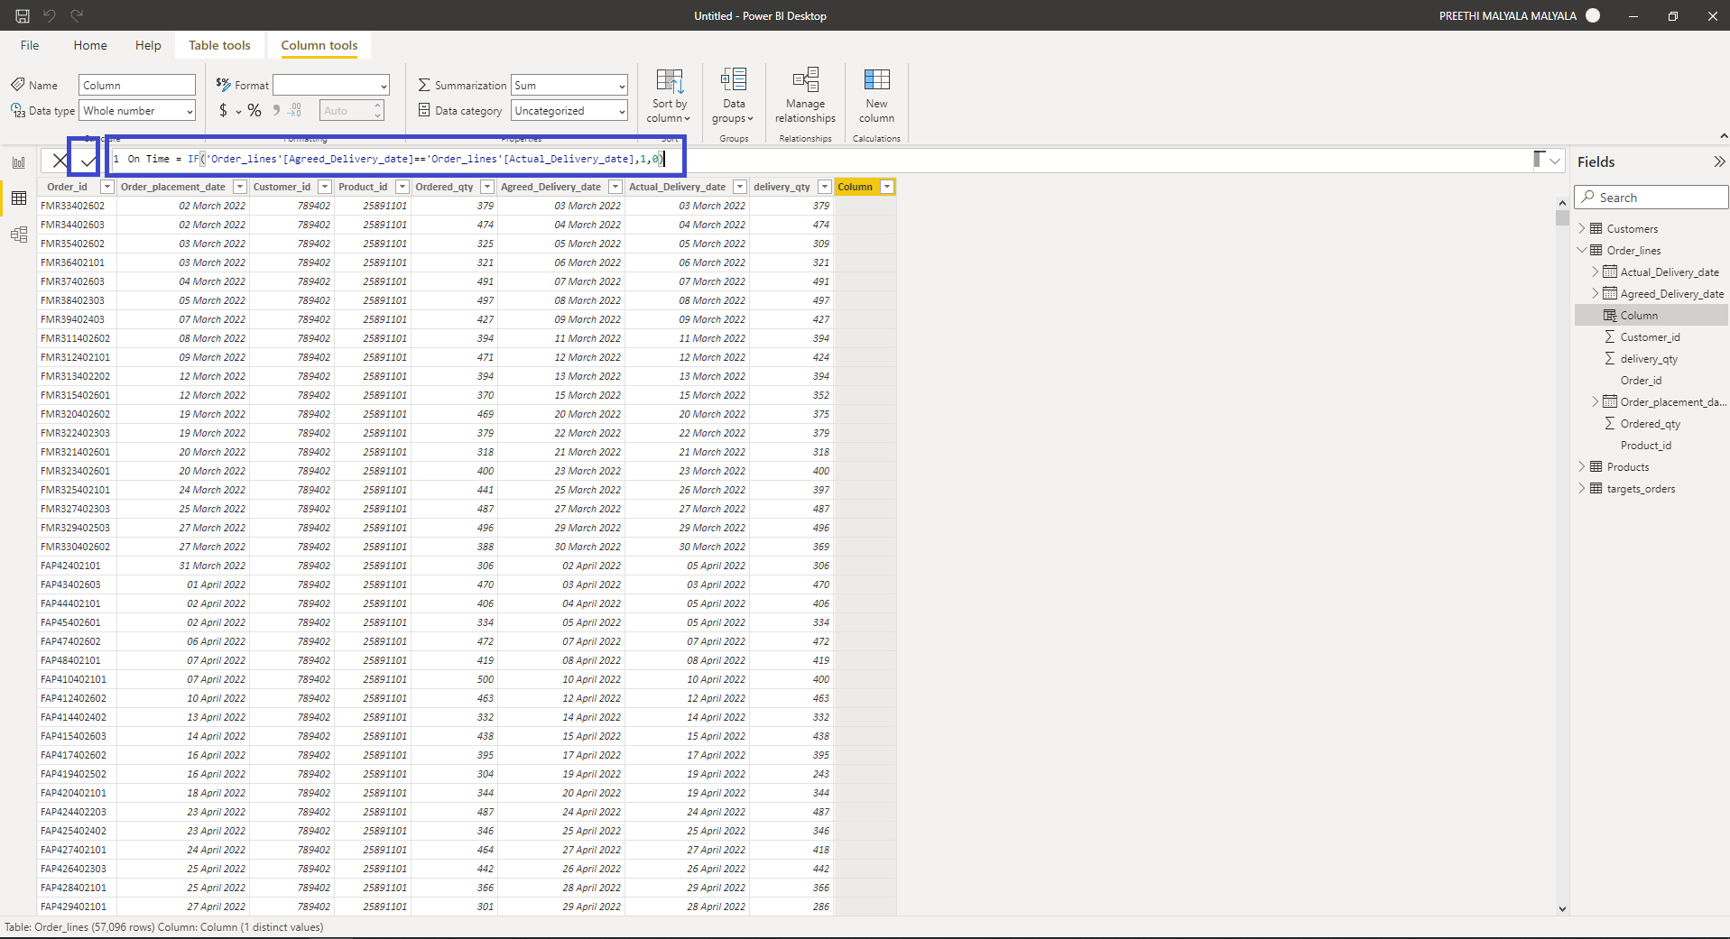

Click On “OK”. Then the column is created as shown in the Fig() below.

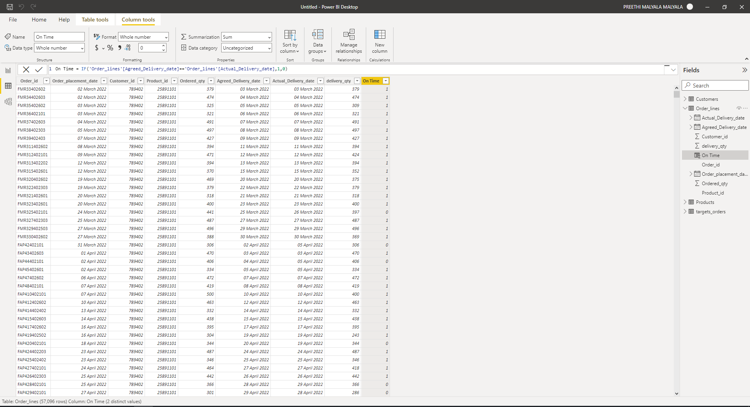

**IF:**

Creating a calculated column in Fact_Order_lines table to find out the In full quantity shipped which makes lot easier to compare the quantity ordered and delivered. The Column has been created by using the below DAX function:

1. InFull = IF
2. ('Orders Table'[order_qty] == 'Orders Table'[delivery_qty],1,0)

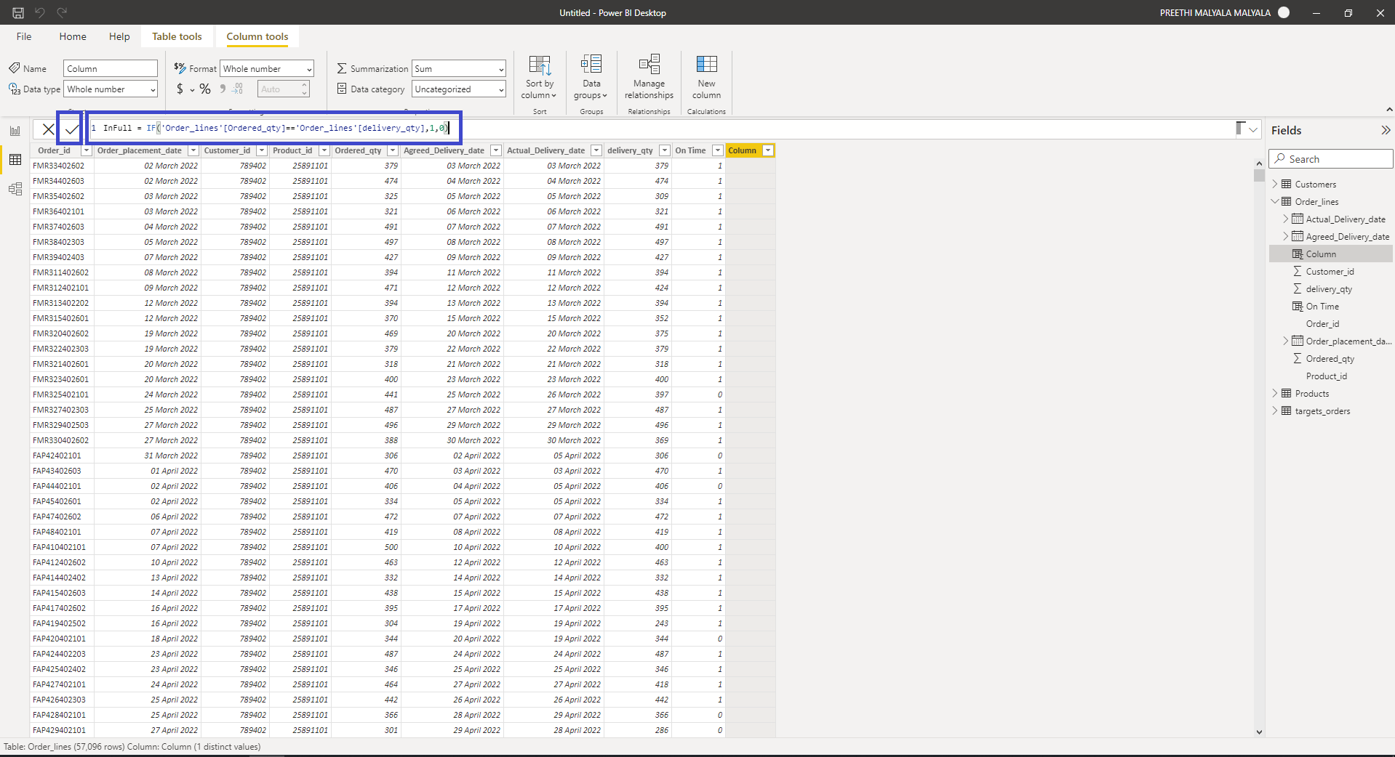

Click On “OK”. Then the column is created as shown in the Fig() below.

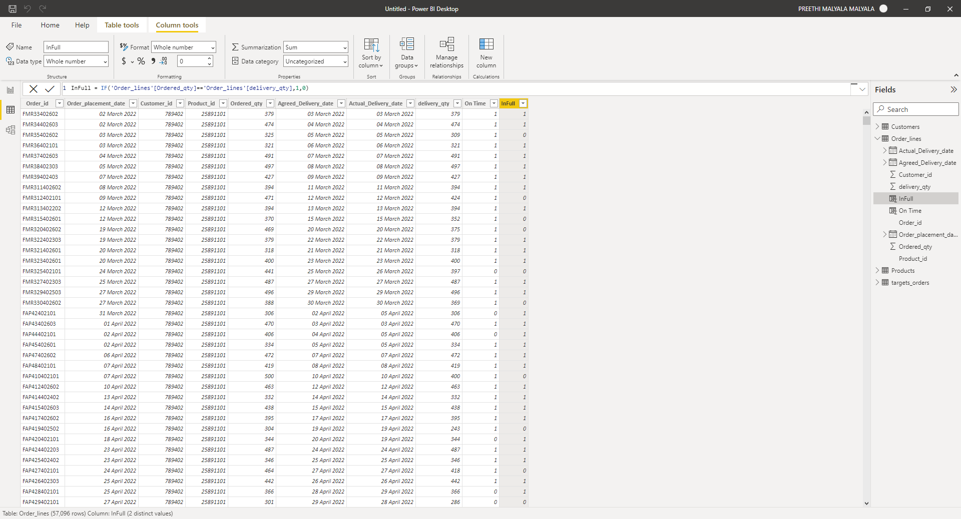

**OTIF:**

Creating a calculated column in the Fact_Order_lines table to find out the order delivery in full and On-time. This helps to find out the count of orders which are delayed in delivery and quantity delivered. Even it help in depth analysis of the orders delayed. Calculated Column has been created by using the below DAX function:

OnTimeInFull = IF('Orders Table'[InFull]==1 && 'Orders Table'[OnTime]=1,1,0)

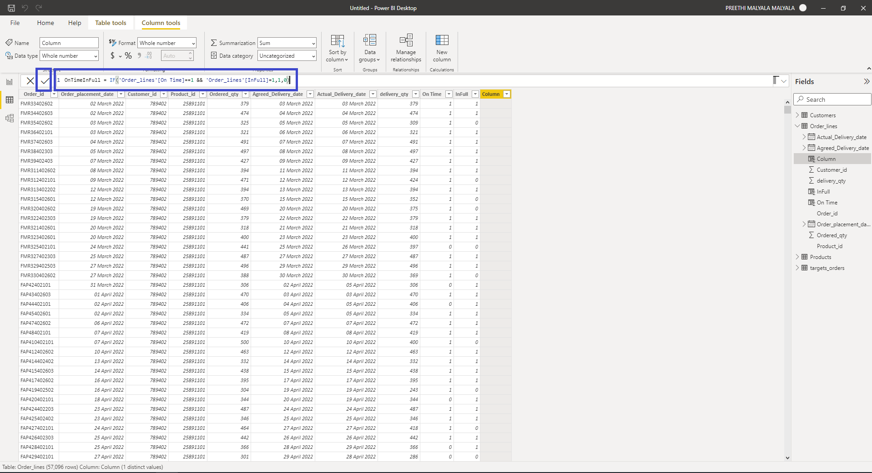

Click On “OK”. Then the column is created as shown in the Fig() below.

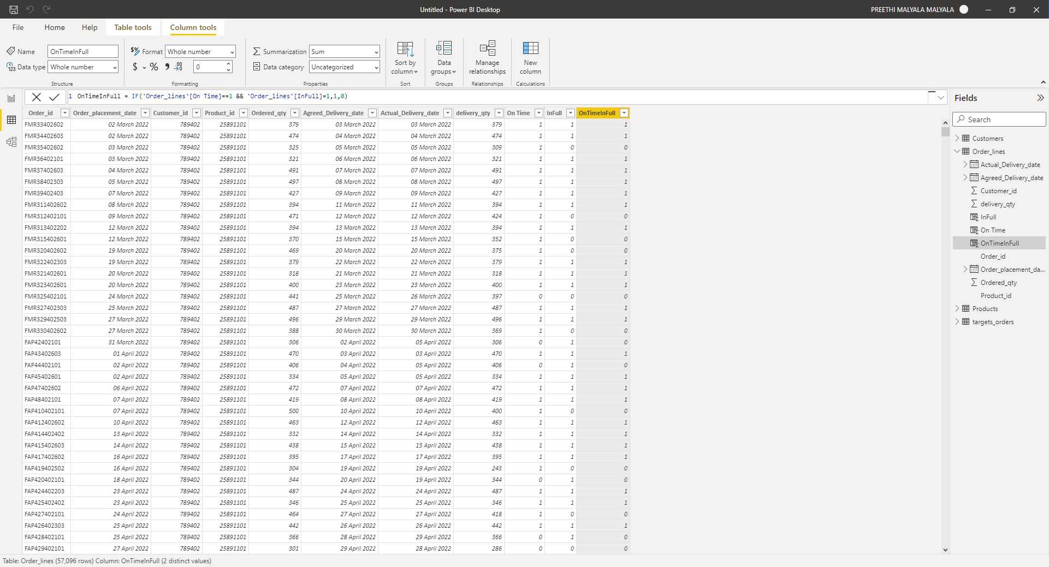

**Measures created using DAX:**

|  |  |  |
| --- | --- | --- |
| **S.No** | **Measure** | **DAX** |
| 1. | **One day delay Orders Count** | 1day Delayed orders count =  CALCULATE (  DISTINCTCOUNT ( fact_order_lines[order_id] ),  fact_order_lines[Daydealy] = 1  ) |
| 2. | **Two day delay Orders Count** | 2day Delayed orders count =  CALCULATE (  DISTINCTCOUNT ( fact_order_lines[order_id] ),  fact_order_lines[Daydealy] = 2  ) |
| 3. | **Three day delay Orders Count:** | 3day Delayed orders count =  CALCULATE (  DISTINCTCOUNT ( fact_order_lines[order_id] ),  fact_order_lines[Daydealy] = 3  ) |
| 4. | **ADDD**: | ADDD = CALCULATE(AVERAGE(fact_order_lines[Daydealy]), fact_order_lines[Daydealy] <> 0, fact_order_lines[Daydealy]<> -1) |
| 5. | **Delayed Order:** | Delayed Order % = [Delayed orders count]/[Total order lines]*100 |
| 6. | **Delayed Order count:** | Delayed orders count =  [1day Delayed orders count] + [2day Delayed orders count] + [3day Delayed orders count] |
| 7. | **LIF:** | LIF = CALCULATE([Total order lines], fact_order_lines[In Full] = 1) |
| 8. | **LIFR:** | LIFR % = [LIF]/[Total order lines] |
| 9. | **Line Share % Monthly per Delayed Days Status:** | Line Share % Monthly per Delayed Days Status = DIVIDE([Total Order Lines],CALCULATE([Total Order Lines],ALLSELECTED(dim_date),AllSELECTED(fact_order_lines[status]))) |
| 10. | **Orders full & time:** | Orders full & time = CALCULATE([Total Orders], fact_orders_aggregate[in_full]=1,fact_orders_aggregate[on_time]=1) |
| 11. | **Orders in Full:** | Orders in FUll = CALCULATE([Total Orders],fact_orders_aggregate[in_full]=1) |
| 12. | **Orders ON Time:** | Orders ON Time = CALCULATE([Total Orders],fact_orders_aggregate[on_time]=1) |
| 13. | **Target Full & Time:** | Target Full & Time = AVERAGE(dim_targets_orders[otif_target%]) |
| 14. | **Target In_full:** | Target In_full = AVERAGE(dim_targets_orders[infull_target%]) |
| 15. | **Target On_time:** | Target On_time = AVERAGE(dim_targets_orders[ontime_target%]) |
| 16. | **Total order lines:** | Total order lines = COUNT(fact_order_lines[order_id]) |
| 17. | **Total Orders:** | Total Orders = DISTINCTCOUNT(fact_orders_aggregate[order_id]) |
| 18. | **TQO:** | TQO = SUM(fact_order_lines[order_qty]) |
| 19. | **TQS:** | TQS = SUM(fact_order_lines[delivery_qty]) |
| 20. | **VORF:** | VORF % = [TQS]/[TQO] |

**One day delay Orders Count:** here we calculate the orders count delayed by a day

**Two-day delay Orders Count:** here we calculate the orders count delayed by 2 days.

**Three-day delay Orders Count:** here we calculate the orders count delayed by 3 days.

**Delayed Order:** Orders which are delayed

**Delayed Order count:** Count of the orders which are delayed

**LIFR:** Line-item fill rate

**Orders full & time:** Count of Orders delivered in full quantity in time

**Orders in Full:** Count of Orders delivered in full quantity

**Orders ON Time:** Count of Orders delivered in time

**Target Full & Time:** Average of in-full and on-time target

**Target In_full:** Average of in-full target

**Target On_time:** Average of on-time target

**Total order lines:** Count of all orderliness in Fact_order_lines table

**Total Orders:** Count of all the Total orders

**TQO:** Count of Total Quantity Ordered

**TQS:** Count of Total Quantity Shipped

**VORF:** (Volume Fill Rate)It shows the total quantity ordered

# **DASHBOARD EXPLORATORY ANALYSIS:**

**Title Page:**

Below fig shows the Title page of the Dashboard which contains the logo of the company. Name of the Project and the Page navigation buttons. Below listed are the pages in the dashboard which I have added in Navigation pane which helps to navigate from one to another.

* Title Page
* Orders
* Orders V/s Target
* Product Analysis
* Order Lines
* Service Level
* Line Lead 1
* Line Lead Analysis
* Key Metrics

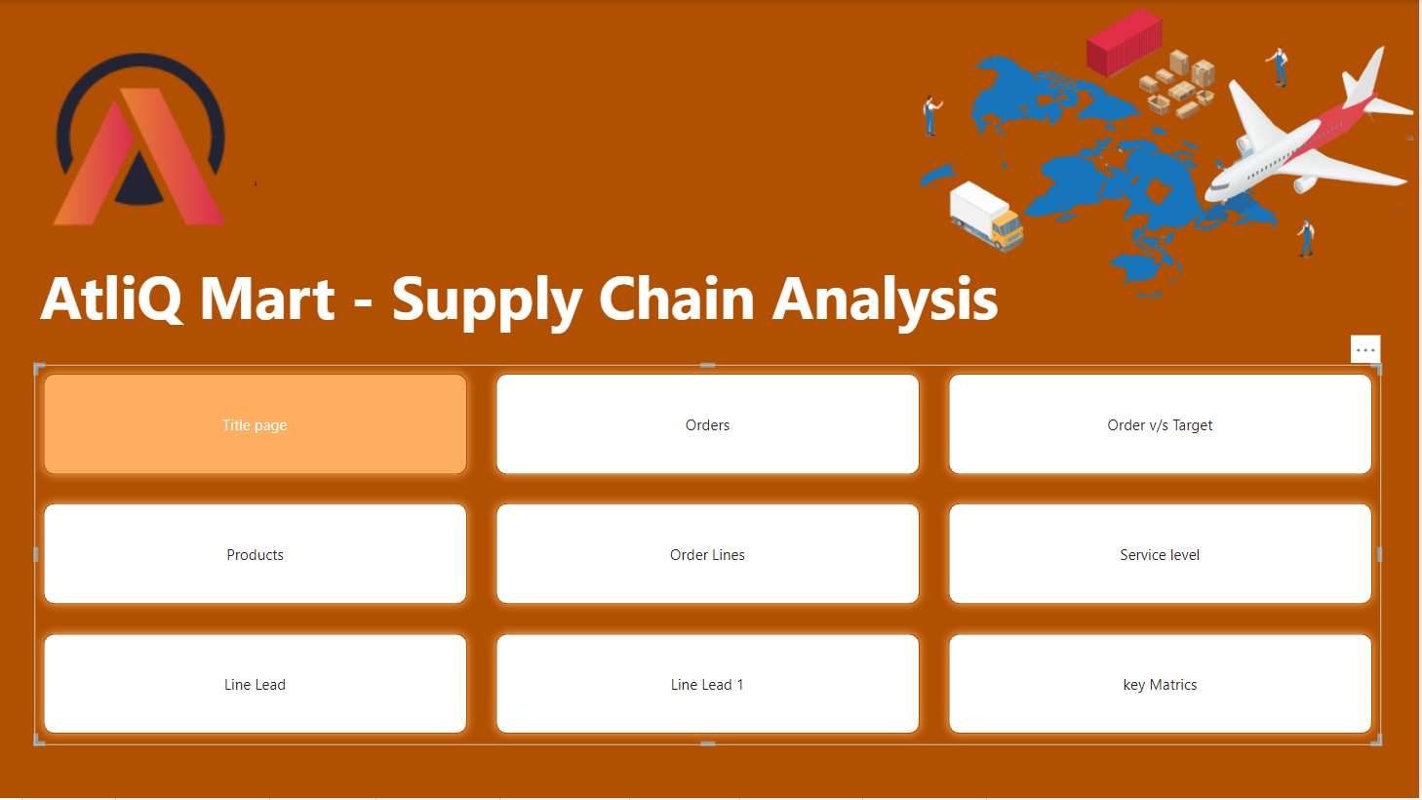

**Orders Page:**

This page shows thecomplete orders at a glance. It contains a few cards which show the Total Orders, Orders on time, Orders in Full, Orders in Full, and Time.

Used 2 bar graphs that depict the Orders based on Categories in different cities and the Orders based on cities in different categories.

The last bar graph shows the cities with the highest order count to Lowest.

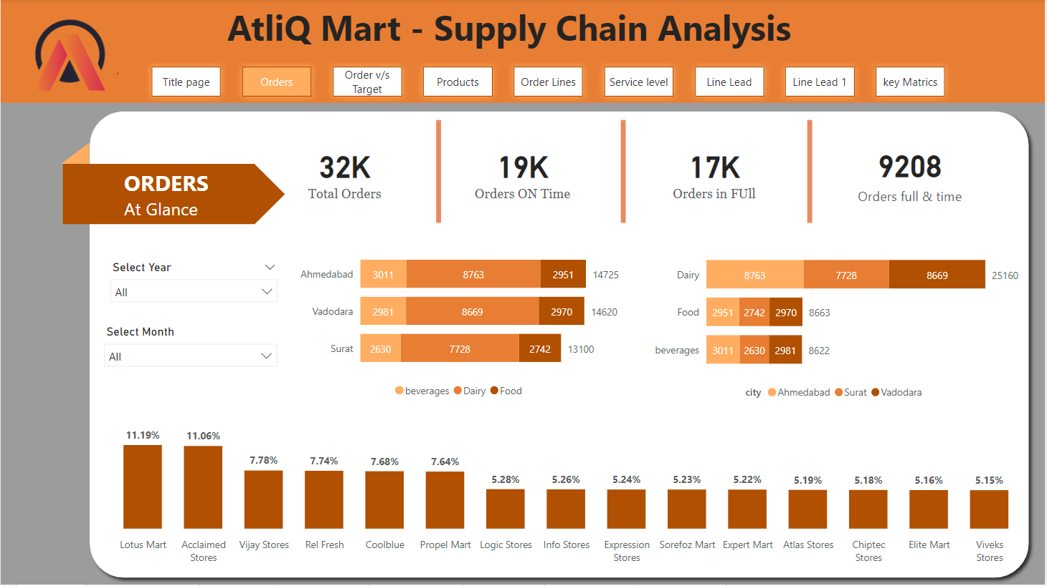

*Fig(): Orders at Glance*

**Orders V/s Target:**

The below page depicts the difference between Actual and target OT%, IF%, and OTIF% which is to check if the company meets the expected target.

The gauge axis is used to show the actual OT, IF and OTIF values with the respected target values.

A card is used to show the difference between the actual and Target values.

The bar graphs show the difference between OT, IF and OTIF values with the target values based on cities.

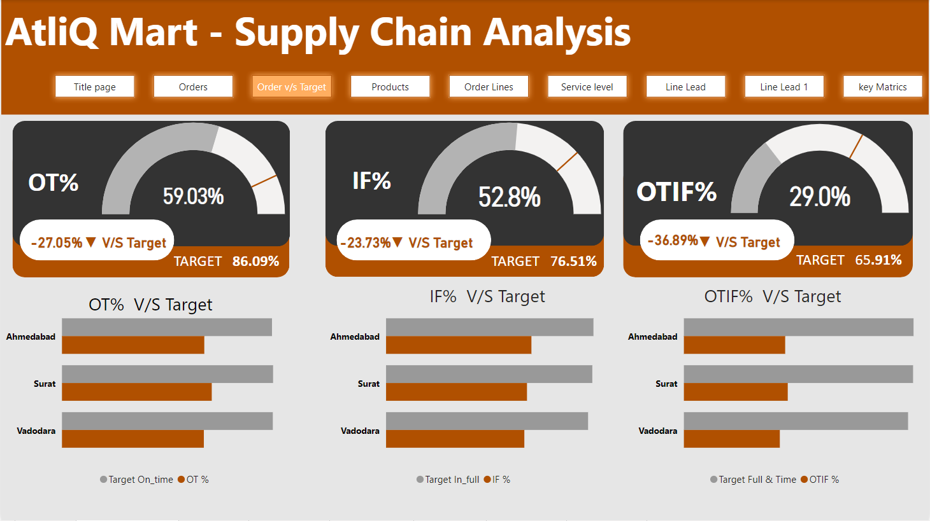

**Order Lines:**

This page depicts the entire order lines where the cards used can clearly show the Total Order lines, total order line quantity, total order line quantity delivered, VORF and LIRF.

The Line and Clustered column chart here shows customer_name on X-axis, Total order lines on Y-axis and LIFR on Line Y-axis.

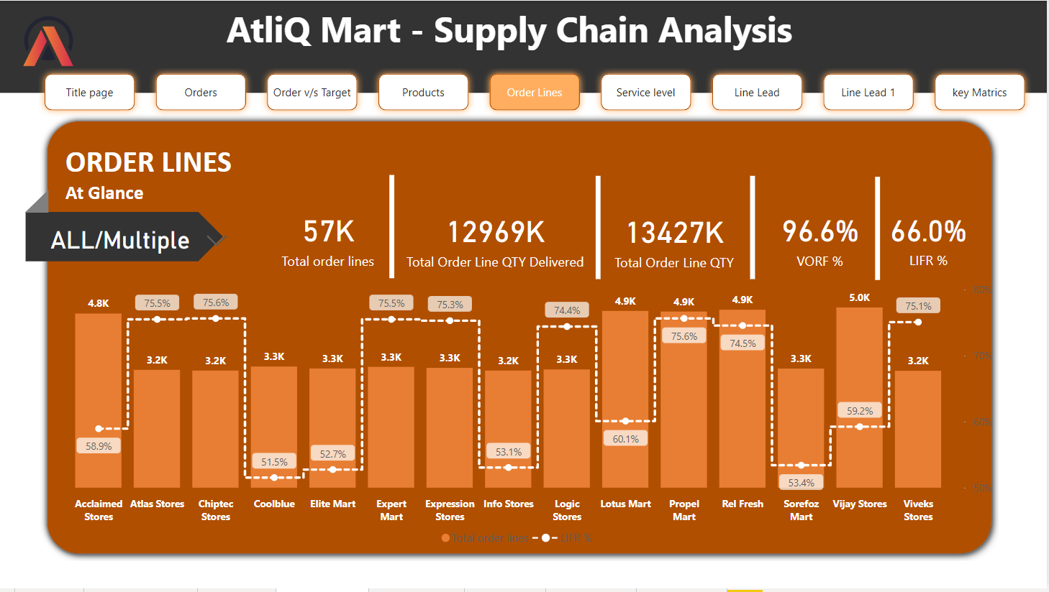

**Service Level Analysis:**

This page depicts the service level analysis based on the Customers against the OT%, IF%, and OTIF%. Table Heat Map here represents the service of the customers from low to high based on the color code. The scatter chart has the customers as Values and OT% on X-axis and IF% on Y-axis and bubble size depends on the Total Line Order QTY.

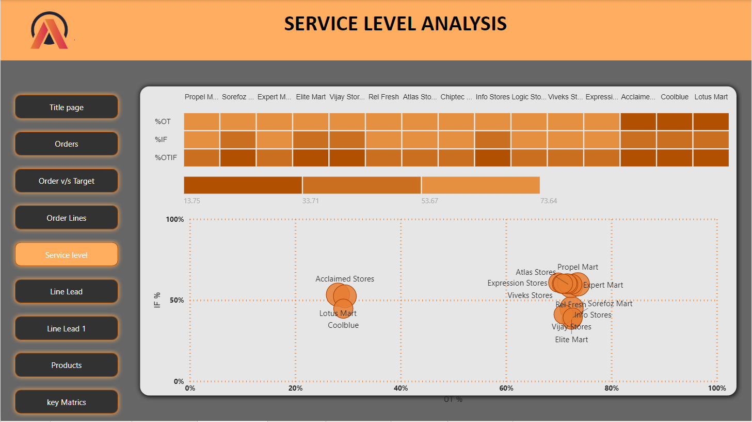

**Line Lead Time Analysis:**

The below page has 2 tables that contain clear data on the orders which are Early, On time and delay in delivery based on the category of food and Cities. Both bar graphs show the percentages of the status of orders based on categories and cities.

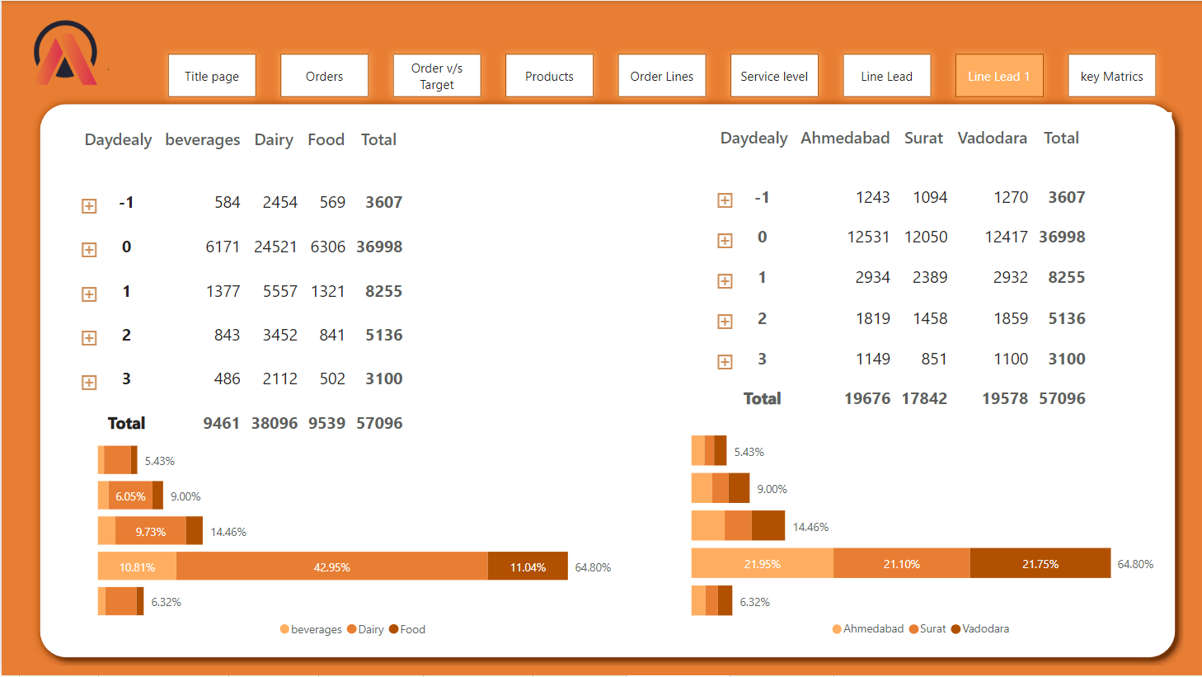

**Line Lead Time Analysis – 2:**

The below page has a Line and stacked column chart which has Customer_name on X-axis and Line share % monthly per delayed day status and LIFR% on Line Y-axis. The legend shows the On time, Early, Delay and LIFR.

The inverted stacked column chart which shows the Customer_name on X-axis and Total Order lines on Y-axis.

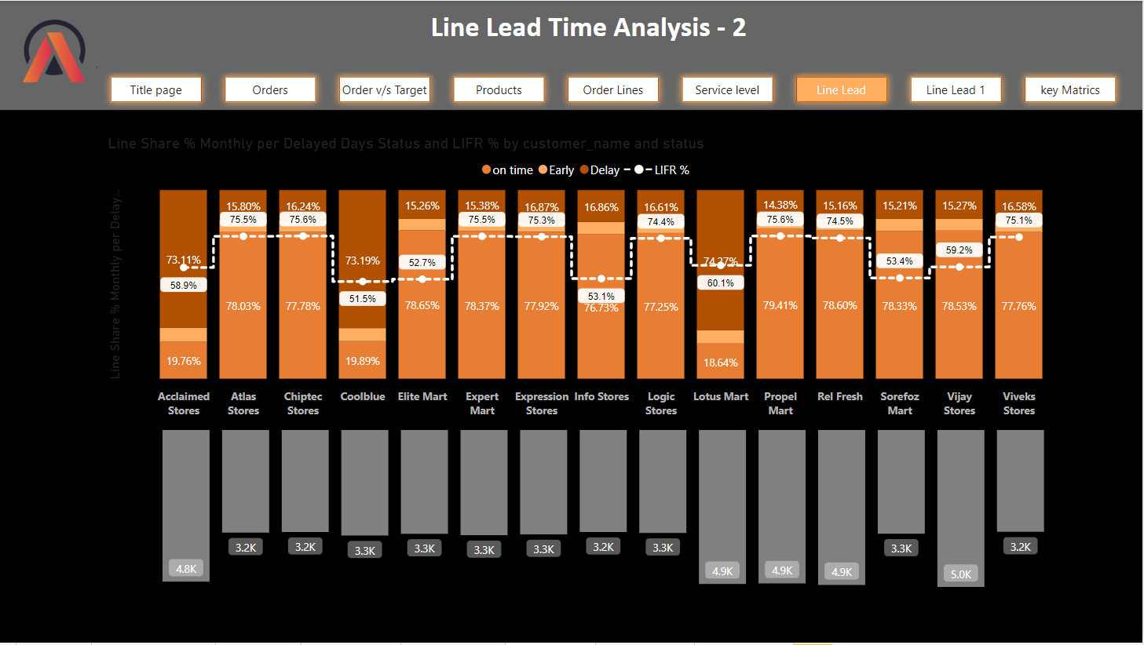

**Products:**

This page shows the matrix table of categories based LIFR,VORF percentages and used Conditional formatting in the table to check the status of LIFR% and VORF% by date in various Categories. The expand/Collapsible icon is placed to show the variety of food discussing in the categories.

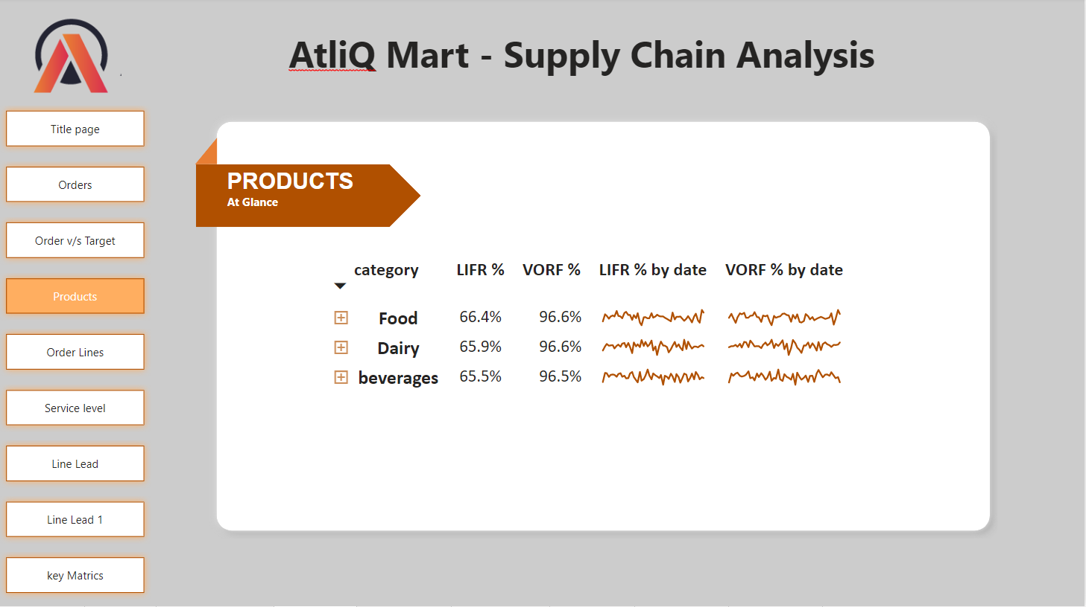

**KEY METRICS:**

This page depicts the key metrics of OT, IF, OTIF, LIFR and VORF.

To depict the various graphs on one page I have used Buttons that I have bookmarked and added the actions which work for both the line chart and Ribbon Chart. I have used a Line chart here whereas Date on X-axis and the values on Y-axis. The ribbon chart shows the same based on Cities.

**OT%:**

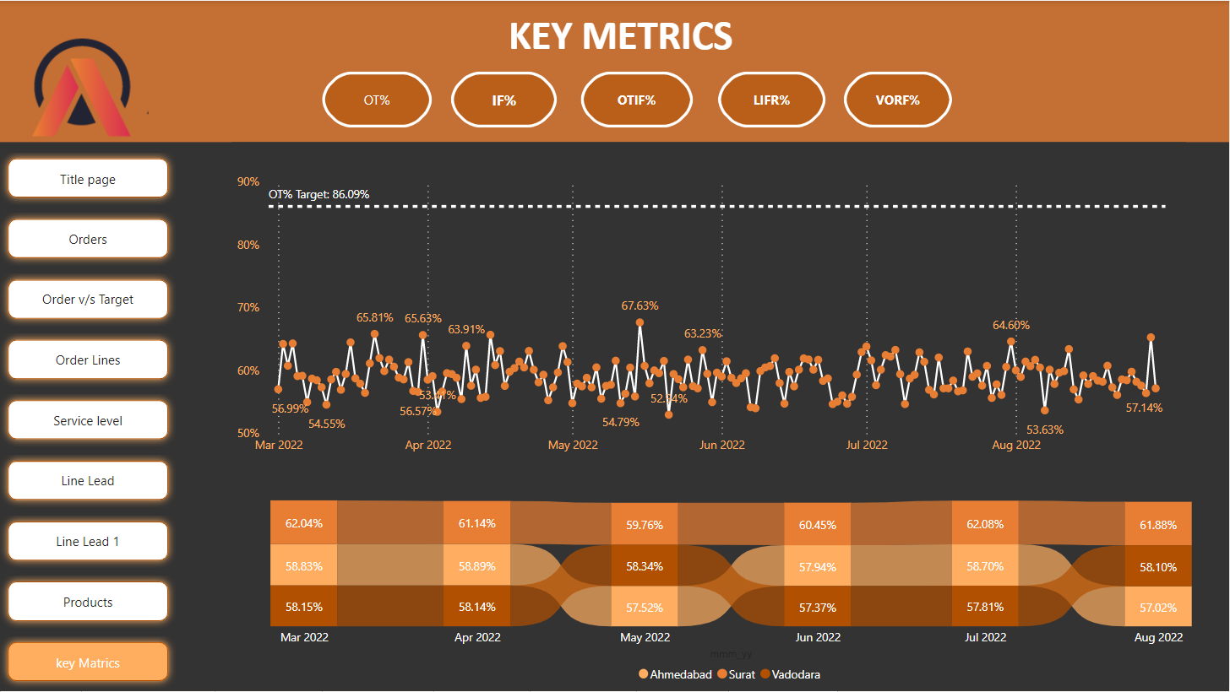

**IF%:**  
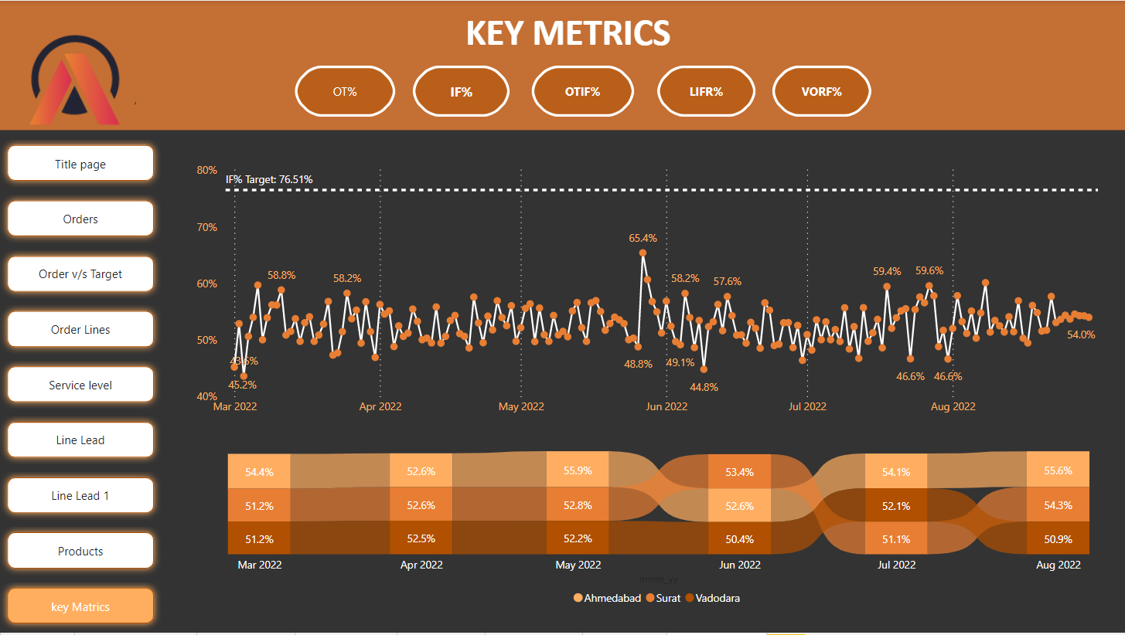

**OTIF%:**

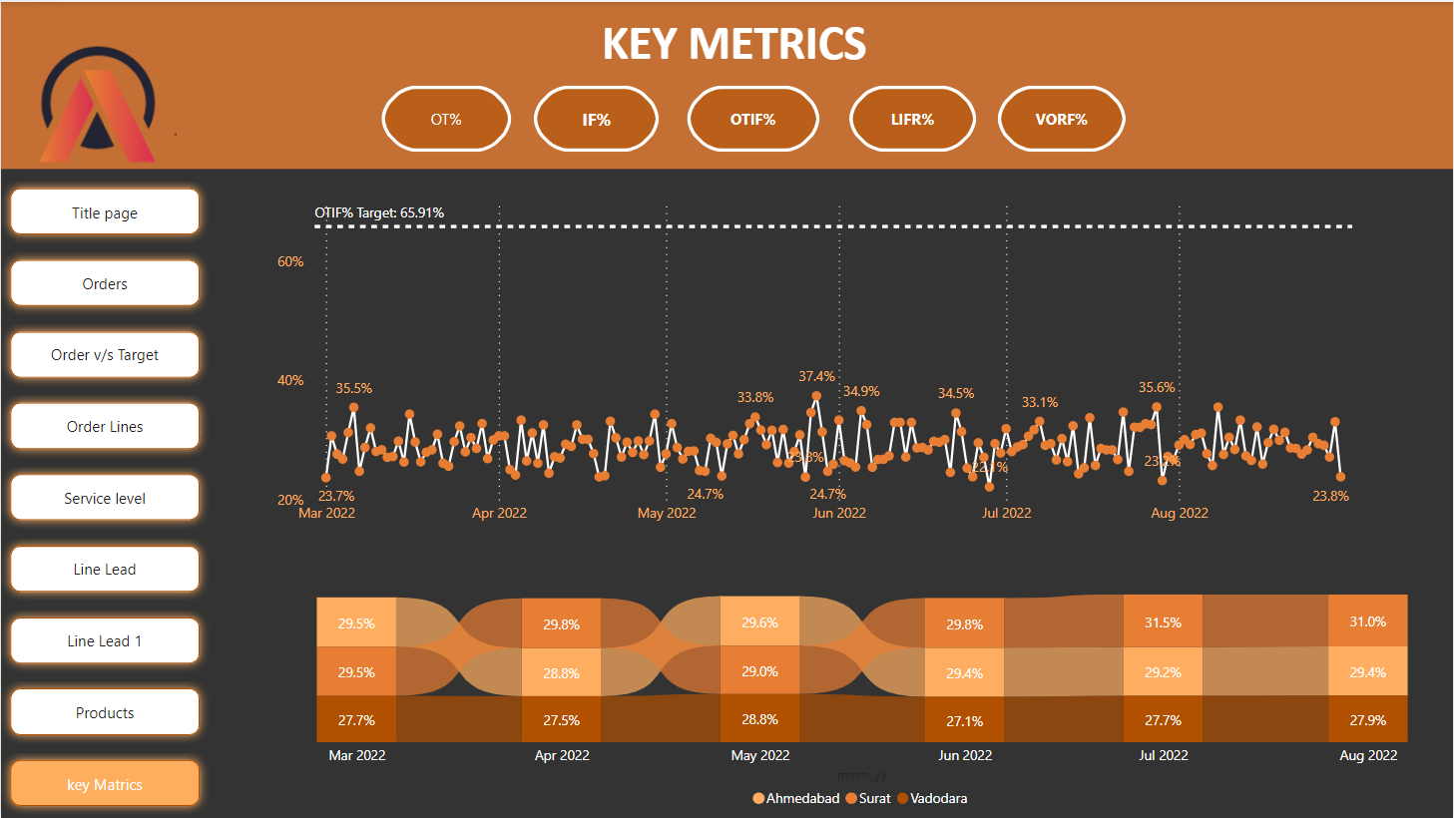

**LIFR%**

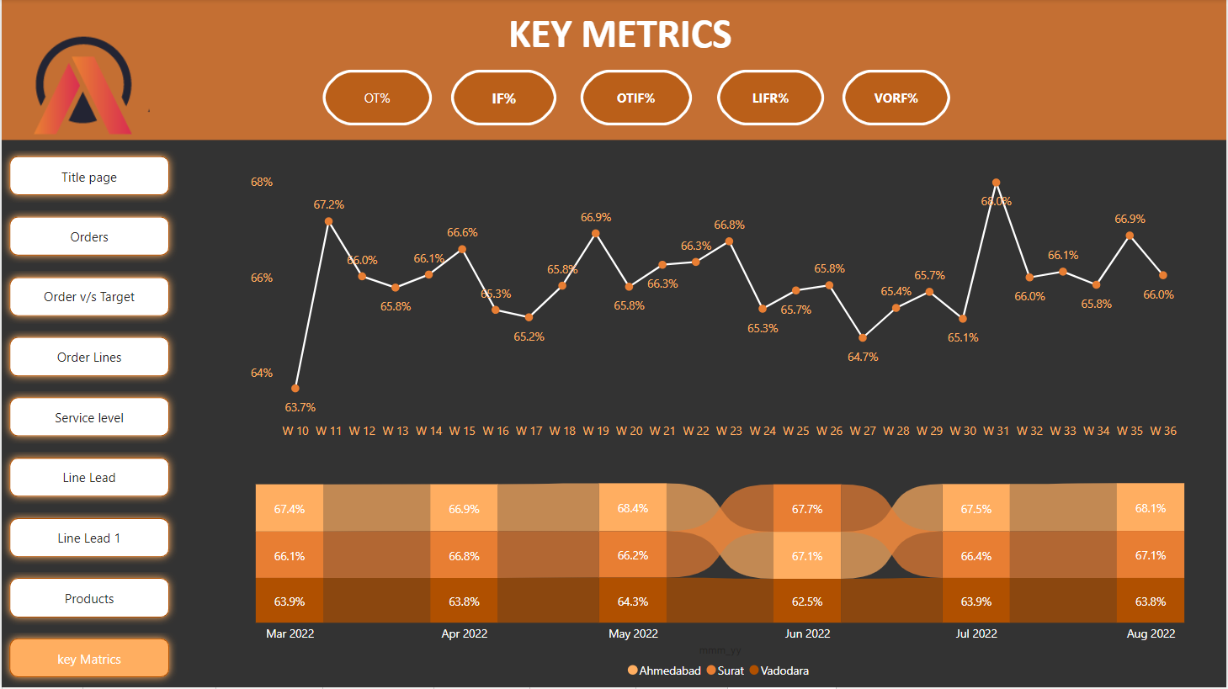

**VORF%**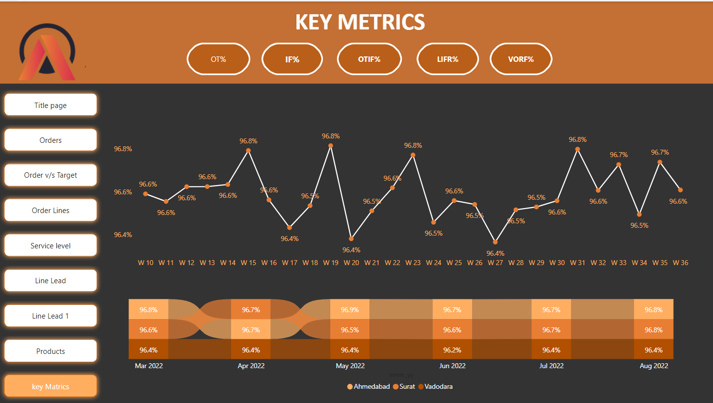

# **References:**

<https://codebasics.io/event/codebasics-resume-project-challenge>

<https://lnkd.in/gfxUiAkc>